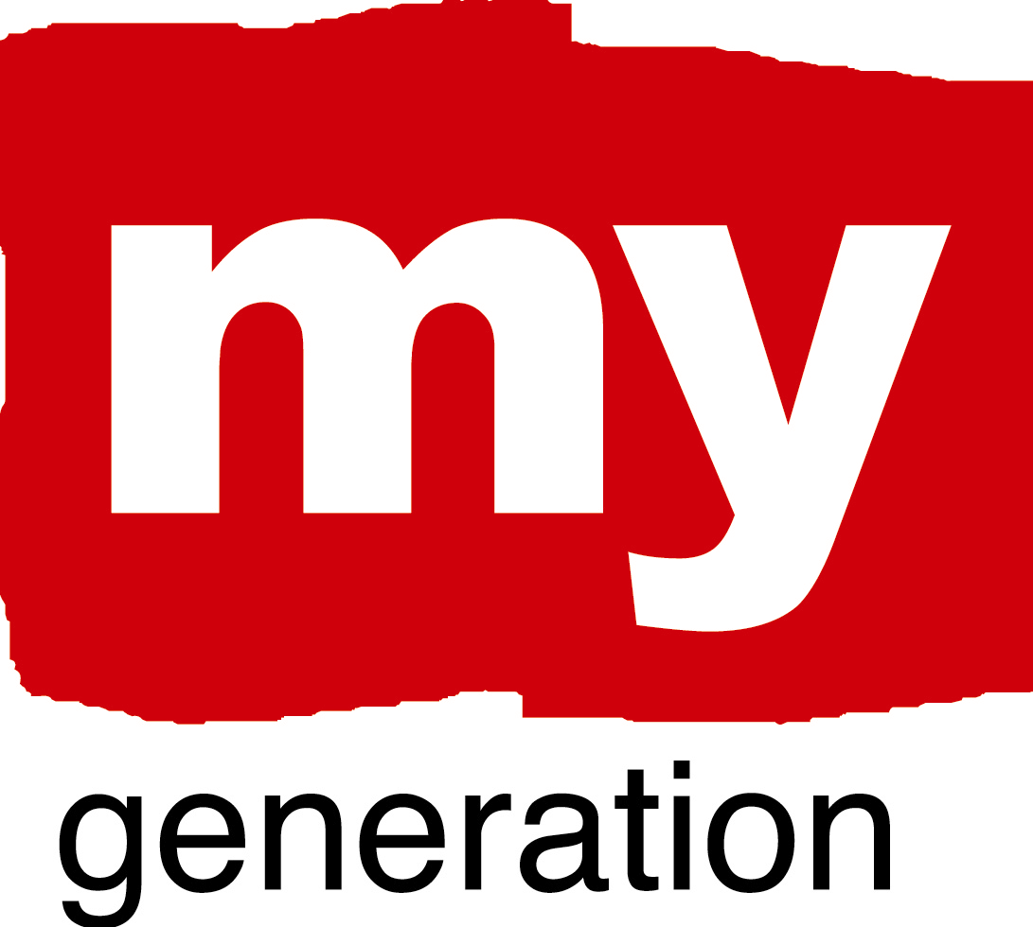

OUTREACH – EARLY LESSONS FROM MY GENERATION

Introduction

My Generation brings together young people from urban areas across Europe. Our network of ten cities promotes the positive potential of Europe’s youth. Working for and with young people, we are learning from one another and creating new ways to collaborate.

One of our key themes is outreach. The My Generation network came together in Glasgow in May 2009 to explore this theme in detail. Each of our cities highlighted one aspect of their approach to outreach and we exchanged practice and developed our ideas for change together. Through the Local Support Partnerships (LSPs) we will be taking this agenda forward in the coming months.

At this stage we would like to share some of the early messages coming from our work in this area. This paper contains key points drawn from the My Generation case studies. They are practical examples developed by our partners which we hope will be helpful for others. The full case studies which are referred to throughout the paper can be found at the My Generation web site.

In the months ahead we will be providing more details guides to some of the work highlighted here.

Through My Generation we’ve found that…

It’s good to get out in the streets

Outreach is about making connections and building relationships. A starting point for many of our partners is many young people’s disconnection from opportunities – for a variety of reasons. Proactively getting out into communities is one of the shared themes through the effective approaches within My Generation. But how are we doing this?

In Antwerp, there are 3 Youth Competence Centres which work in localities with high numbers of disengaged youth. The YCC De Branderij is one of these. It works with youngsters aged 5 to 25, and 75% of their service users have Moroccan roots.

The YCC uses a neighbourhood youth engagement model, relaying heavily on staff who have grown up locally and who have a good handle on community issues. Workers know the patch well and are comfortable engaging with youngsters in meeting places where the youngsters are at ease. Most of the work is conducted out in the community and the YCC is described as ‘an extension of the street’.

The YCC facilitates a wide range of activities – 186 in 2008 – with a strong focus on themes of interest to young people. A central part of the approach is the role of the animators, voluntary youth workers, trained by the YCC who facilitate these events. The YCC model (from consumption to participation) provides a pathway from the streets to professional careers in a highly visible way. Neighbourhood youngsters identify with the youth workers who provide very positive role models within the community.

Other My Generation cities have similar approaches at the heart of their engagement activity. Notably, they include:

- The Birmingham Streetgames model also focuses on specific neighbourhoods where young people are at risk of social exclusion. It utilises sport, dance, DJing and other activities in the community to establish relationships with these youngsters – and their families
- Partners in Valencia are working together to connect with and support marginalised young people who are ‘lost in the city’. The case study focused on a neighbourhood (La Creu del Grau) with very high levels of youth unemployment, and involved youth associations, neighbourhood bodies and education providers. Using a flexible and wide range of activities, they are reconnecting with these youngsters through getting into their barrio.
- In Glasgow, hot-spot neighbourhoods with high levels of anti-social behaviour are specifically targeted through the use of real time intelligence. There is a particular focus on tackling territorial gang-behaviour through outreach activity and through encouraging positive choices. The outreach tools include mobile facilities including 5-a side pitches and urban cafes.
There is no single approach to this…”whatever it takes”’ is what works best

Gdansk has developed an exciting area for skateboarding and other urban sports within the disused dockyard area of the city’s waterfront. The development of this has brought together young people, NGOs, the municipality, and the Baltic Property Trust which owns the premises.

This grassroots development evolved from initial work led by MOSIR to establish 3 outdoor skateparks in some of the city’s most deprived areas. This arose from dialogue with youth in these areas who complained about the lack of recreational facilities. The success in working with young people to deliver these facilities led to a bigger opportunity – to transform one of the city’s most iconic public spaces into an indoor skatepark.

These ideas fitted well with other plans to site NGOs providing support to young people with addictions in the waterfront area. The connection between extreme urban sport and being substance free edge had an obvious appeal for all of the key partners.

The design and construction of the facility involved over 60 young people, many of whom were outside mainstream society – so not engaged in education, employment or training. Through their involvement, young people were able to utilise their skills and knowledge, as well as gain an insight into the employment prospects available within the partner organisations in the voluntary, public and private sectors.

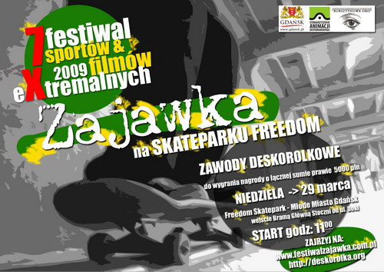

Also…

- Every summer there is a ‘youth month’ in Riga. The format of this is shaped by the local recreational education institutions and the Riga students’ Youth Council. Designed to encourage all young people to ‘come and take part’ it is another example where public spaces are given over to young people. In 2008 the wide range of events included the Baltic Graffiti Festival, the RIDEIT Mask Ball (BMX and skating) and a Rat Race through the city’s historic district. Informal learning is its heart and last year 15,000 participants got involved.

- Like many ports, Patras currently faces challenging issues relating to illegal migration. ‘Each One, One World’ is a new approach to promoting positive collaboration between communities and between generations. Patras Youth Council co-ordinated the activity, which brought together large numbers of participants who made movies, cooked, danced and talked together. After 10 days of preparation the event took place in one of the city’s most beautiful old buildings where during the graffiti production…’walls were sacrificed for art.’

We need to join up the offer

Making the initial engagement with young people is a start – but it is only that. We can see across My Generation that the most effective outreach approaches are ones which are supported by an attractive set of options for young people to choose from. Without this, the relationship brokered through the initial outreach work is hard to sustain.

The approach in Glasgow is one where young people engaged by the partners are offered a series of choices. Through intelligence gathering and sharing, Glasgow Community Safety Service (GCSS) and its partners identify young people involved in anti-social behaviour which is often gang-related. The initial choice is between engaging with support services or electing to continue with their gang-related activity and face the legal consequences.

For many, the opportunity to break the gang cycle is a relief and most who are approached take up the offer of support. Initially this involves a needs assessment before referral on to one of the many available interventions. The menu of support includes services delivered in schools, with families and within local communities – for example through NGOs and colleges.

The programme also involves the city’s two principal football clubs. Visitors to Glasgow in May visited the development work at Rangers FC, where many young people participate in interventions designed to promote their core skills. Using the powerful Rangers brand, partners are able to attract youngsters who have been switched off from learning, working with them to build confidence and highlight their skills for work.

Beyond these core skills interventions, Glasgow provides pathways into employment through a divergent range of opportunities. These include apprenticeship in sectors like Construction, work placements and volunteering slots. Again, visitors to the city in May met with former gang members who are in the final apprenticeship stages with City Building, a construction business linked to the municipality.

Young people who progress through this process see their lives transformed from gang members outside mainstream society to skilled workers with good career prospects. Living in deprived communities they provide powerful role models for younger people who have seen this change process and the benefits it can bring.

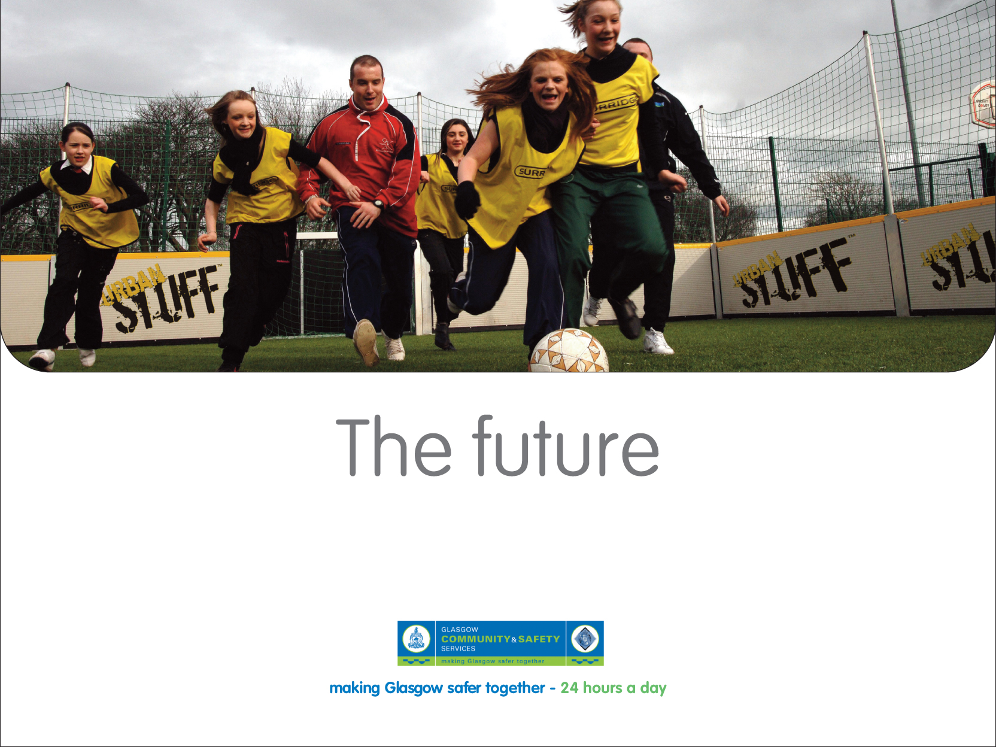

- In Gothenburg the ‘Young and Safe’ model brings together all of the city’s key players involved in preventing youth crime and anti-social behaviour. With support from the highest level in the city, the approach has played an important role in reducing youth crime levels. It has done this through effective collaboration between partner organisations. Achieving this required a strong message of support from the city’s leaders and significant investment convincing staff across key agencies, led by a secretariat of champions from each of the key players. A good example of Strong and Safe in action is in the district of Backa. There, youngsters who have struggled to complete their education are offered internships with a local housing association. There they can acquire skills and experience which can help them progress in future.
- In Tirgu Mures it has been difficult to engage children of Roma families in education. A collaboration between the local authority and two international NGOs was designed to tackle this issue. Through a programme of summer activities and a focus on supporting traditional Roma cultural activity (folk music and arts) a stronger connection was built with the youngsters. At the same time, an elementary school unit was established, (the Rainbow Elementary school) which now has 92 pupils aged 5 to 17. Half of these pupils progress onto either high-school or vocational school, in spite of the community’s traditional hostility to formal education.

Structured pathways are attractive

As in Antwerp, colleagues in Rotterdam have also found it important to adopt a proactive approach to outreach, taking them into the city’s most disadvantaged areas. The City Mobile Team Youth Work was established through the need for a rapid response youth work unit able to work in all 13 districts of the city. The model which has evolved is one where junior youth workers, often from deprived neighbourhoods and communities, work closely with more experienced professionals. This blend of youth and enthusiasm combined with skills and experience has proven to be a highly effective one.

One important feature has been the development of a structured professional development pathway for the young people who join as junior youth workers. This has been produced by Rotterdam University with financial support from the city council. For the first year of training the youths are employed by the Youth Foundation with their salary paid by the City Council. After this initial year they are expected to find work whilst completing their training.

Traditionally, there were high turnover levels amongst junior youth work staff, partly because the professional pathway into a youthwork career was unclear without formal school qualifications. As well as providing an effective and innovative service, the Mobile Youth Team model has helped with recruitment and retention. This approach provides an opportunity for streetwise young people to work, earn money, gain qualifications and access a professional career all at the same time!

- Other My Generation cities are using approaches which allow young people to gain qualifications and work opportunities, despite leaving school with few prospects. In Birmingham, the Streetgames model brings youngsters into contact with FA (Football Association) qualified coaches. It also provides opportunities for young people to acquire FA coaching qualifications which can lead to future employment. In Antwerp there is a similar approach which encourages young people using services to consider careers as qualified youth workers – a process they call ‘from consumption to participation’

Where to next?

My Generation is at an exciting stage. As we get to know one another we can feel the energy and potential that’s in place across the network. In the coming months we’ll be working to harness this to produce new and innovative products designed with young people in mind – developed with them and tested by them. We will also be examining some of the approaches discussed here in greater detail so that we have a better understanding of how they were designed and delivered. The aim of this will be to support other cities to apply these approaches in their own contexts.

In the meantime, you can keep in touch with these developments – or tell us about your own outreach experiences via our web site.

Eddy Adams

Thematic Expert October 2009

http://urbact.eu/thematic-poles/social-inclusion-and-governance/thematic-networks/my-generation/useful-documents.html#c3019
Municipal Centre for Sport and Recreation

