
The Youth Competence Centres of Antwerp

A Case Study about the synergy between ‘Outreaching Youth work’ and ‘RAC-guidance’:

- Introduction:

In 2006 the city of Antwerp started with the idea of developing Youth Competence Centres (YCC). A steering-committee created a concept and defined the following mean objectives:
‘The Antwerp Youth Competence Centres are accessible centres for young people that provide integrated activities regarding leisure time, competences (identification, development and recognition), education and work/employment. These three accesses are all profoundly developed and the interaction between these accesses is the foundation of the YCC. The YCC’s are explicit learning and development spaces that empower young people with a view to personal development and increased social orientation and participation. It’s a place were different methods (education, youth work, RAC, employment, …) meet each other to strengthen the integration of young people/ to strengthen their talents.
The lifestyle and needs of young people are central in the activities of the YCC’s’.

The priority target group of the YCC’s are 16 to 25 aged young people in a vulnerable situation (young people in a weak socio-cultural or socio-economic position).

The following model gives a good overview on the YCC concept:

Work/ education
Youthwork

RAC-policy
Informal:
Direct focus on Young people rmeljongeren
Formal:
-Diffusion of expertise towards schools, youth organizations, ..

The motive to create these concept in Antwerp was plural:

- High amount of children born in a vulnerable situation
- High amount of unqualified school-leavers
- High amount of students with a school delay
- High amount of unemployed youngsters
- High amount of youngsters that play truancy
- High amount of unemployed youngsters that we cannot reach in a positive way with our regular employment actions (accompaniment and education actions)
- The European objectives on lifelong learning
- The conviction that young people gain important competences in other places then school.
- The belief that it’s important to invest in the talent of our youngsters.
- ...

Self-evident we realised that the concept of YCC wouldn’t solve everything (cfr. motives) but by working on an integral way, starting from an informal setting and by focusing on competences awareness and a rather young age we think we can prevent certain problem situations for the group that we reach. The Youth Competence centres are a synonym for outreaching. If we want to achieve our goals we need to reach young people in a positive way. In the implementation of the youth competence centres, which is taking place now, we invest a lot in methods to reach the target group. In these case study we will focus on the outreach practice of one of the Antwerp Youth Competence Centres: YCC De Branderij that is runned by JES. These organisation operates in three Belgium cities Brussels, Antwerp en Gent. Next to the Flemish allowance they get money from the local cities to implement youth work and employment actions. In Antwerp JES is mainly focused on the development of Youth competence centres.

Antwerp counts three Youth Competence Centres each with their own specific accents in their organisation: YCC ZAPPA, YCC Deurne and YCC De Branderij. In total the city works together with 5 partners to achieve these project. For more information you can check the partners website:

- www.jes.be
- www.zappaworld.be
- www.kidsvzw.be,
- www.levanto.be
- www.werkhaven.be.

- An outreaching case: Investing in Youth workers out of the neighbourhood

These case is focused on the youth work part of the YCC’s. YCC de Branderij provides a wide range of activities regarding leisure time: on the one hand JES supports local youth work by letting the youth centre and sports infrastructure and by supporting local dance and fight sport clubs. On the other hand, JES provides training for youth work volunteers, youth work activities focussing on the local neighbourhood and cultural youth work activities.

A view on the Youth Work part of JES in the YCC:

Target group: In the first place the attention goes to youngsters with less chances. Te age of the target group varies from 6 to 25 years, 75% of the target Group has Moroccan roots.

The year operation: During the year there is an active offer on Tuesday and on Thursday evening and Wednesday and Saturday in the afternoon. Next to that they organize big events.

Annual range: In 2008 neighborhood youth force organizes 186 activities. 11.909 participations wore counted. The average number of participants was 65.

Activities offer: The organized activities are diverse. The ‘instuif’ en the ‘cyberinstuif’ focuses on meeting other youngsters and the YCC workers in a non-formal way. Next to that there is an offer of sport, games, music, … Weekends and day trips are also part of the program.

Principles:
- The force and talents of young people are the centres starting points (positive approach)
- Young people are themselves instigator, director and manager of their project.
- The YCC wants to stimulate lifelong learning and to respond on the talents of youngsters.
- The YCC tries to use the strengths and advantages of great cities
- The YCC wants to be accessible youth work, both in a psychological, financial and geographical sense.

Accessible and inviting: The centre wants to have a big accessibility and succeeds very well in that. For the young people YCC Branderij is the extension of the street. They work on the rhythm of the youngster and the staff as much as possible coming out of the neighbourhood and out of the target group. JES also works ‘reference adressed’ (vindplaatsgericht) the workers know the neighbourhood and the meeting places of the youngster very well: they organise football games in the neighbourhood, have contact with the parents of the young people in the tearoom, ...

A short chat with Mustapha about he’s outreaching activities in the neighborhood:

- Reference addressed working means what in your job?

- Mostafa: We focus on the neighborhood of the YCC. Not only on the street but for example also in bars. Once you’ve gained trust it’s prominent how much questions you gain about work and education.

- How is the relationship with the parents of the young?

- Mostafa: The relation is really fine. I know most of the parents of the youth that I meet her daily. When I meet their parents I get questions about their kids. I do not tell them everything I know, When it’s necessary I try to mediate.

- What are you doing when you notice that there are big problems in the home situation of a youngster?

- Mostafa: For me the neighborhood is one big family. If there are problems I try to help.

Network: The activities of JES are embedded in the city/ area network. There are regular meeting with the city, with other youth organisations, local schools, area committees, self-organisations, ..

The staff that organises the leisure activities: One employed/ professional youth worker and 20 voluntary youth workers (9 animators and 11 head animators) who are trained in the YCC.

Volunteers: Wednesday- and Saturday afternoon two animators and 2 head animators are (co-)organizing the activities. Tuesday- and Thursday the volunteers are free to help. During the vacation daily 1 head animator and one animator are organizing activities.

History (door Mostafa Ameziane, Moroccan youth worker): from organizing for to organizing with – from consumption to participation

Mostafa is working for JES since 2001. In the beginning he was offered a part-time job next to another youth worker. Those days Youth Center ‘the Branderij’ had to deal with different problems: lack of respect for the material, aggression, … The problems were caused by the frustration of the local youth. They could not get in to the building on a regular base, the youth worker did not know the neighborhood that well, …

Because Mostafa growed up in the neighborhood, he could more easily gain trust of the local young people. Gradually he succeeded in the organization of ‘instuifmomenten (meetings)’ without any problems. In 2006 the other youth worker left JES and Mostafa had to do the job on his own. Rather accidental these lead to the choice to give adolescents more responsibility in the center. The courses to get animator- and head animator pointed out to be a perfect instrument to train the Young people to be a good volunteer.

Mostafa’s job in the neighborhood youth work today look totally different than a few years ago. These is caused by the focus on competences and the responsibility of the young people since 2006. Young people are more consequently stimulated in their accompaniment (route). Mostafa’s tasks are gradually shifted to the second line: coaching of the (head) animators, help o make plans, to feedback, act as go-between, to reflect,… A good example is the management of the computer rooms. In the past Mostafa had to be present when there was youth. Now is this the responsibility of the animator. Afterwards Mostafa and the animator reflect how the activity passed by.

Mostafa’s career is an example of successful RAC-management. Mostafa made a big and positive evolution in his job. Based on he’s earlier gained competences and the believe in Mostafa’s talents they gave Mostafa eight years ago the chance to start as a youth worker without having the right certificate. Now YCC the Branderij is gaining the benefit of these investment. By giving a young guy of the neighborhood the chance to have a key role in the neighborhood the other young people gradually were more positive about the youth center. By seeing that one of them did get a chance and through the sincere investments in participation and involvement they felt respected and did more and more come to the center and gradually took responsibility.

The evolution of consumption to participation was an important key in these case!

- RAC Guidance as an important instrument in the binding and involving of the youngster:

Thanks to the recognition as Youth Competence Centre, the City of Antwerp provided JES the necessary funding to hire a ‘RAC-counsellor ’ (RAC = Recognition of acquired competences), whose mission was to put into practice the objectives of the YCC. The structure that the RAC-guidance imported in the organisation lead to a higher quality and a bigger efficiency in the guidance of young people.

The most important questions and challenges that JES addressed during the experiments were:
- What is RAC-guidance?
- How to integrate RAC guidance in leisure time activities without formalising informal time?
- How and when to start RAC-guidance?
- What is the role of the ‘RAC-counsellor’?

After one year of experiment, 52 young people participated in a RAC-guidance during one or more different projects. More than 50% of these young people participated in more then one project. 26% of the RAC-guidance took place in cultural youth work activities, another 26% in youth work activities with focus on the local neighbourhood. 35% took place in training for youth work volunteers, 5% in job counselling and 8% in specific guidance (social (re)integration).

35 other young people who visit our youth centre got counselling on specific questions concerning school or work. 62% of the young people that took part in the RAC-guidance used the C-Stick portfolio (more information about the c-stick you can find in attachment 1) .

Two practical examples to illustrate RAC-guidance:

Cultural youth work activities

Oliver, a 14-year old boy with Serb roots lives in front of the YCC. Unless his curiosity, he felt shy to find out what was happening in the centre. He thought that he would not fit with the others, mainly boys with Moroccan roots. During the project SHOOT! (a yearly event where the fusion between football and cultural activities attracts a lot of young people from the neighbourhood) we asked him to participate as a photographer. The role as reporter suited him very well.

The RAC-counsellor gave him a C-Stick where he could gather his photographs and showed him how to use it. Oliver liked to ‘pimp up’ his C-Stick and use it as a trendy passport.

Nevertheless, there was a day we couldn’t respond to Oliver’s curiosity anymore, because we don’t provide professional training in photography. Oliver was then referred to Stamp Media, a youth press agency. Oliver could use the C-Stick to show his former photographs. Stamp Media was immediately convinced of his talent and hired him. He got some extra training and to improve his reporter skills, he also got a training in communication skills. During the learning process the RAC-counsellor regularly gave feedback and this feedback was also stored on the C-Stick.

Oliver got insight in his own learning process and made a lot of plans to develop his own competencies. In the mean time Oliver told us that he was very unhappy with his school career, which resulted in disinterest and problematic behaviour in school. Based on the things he learned during the RAC-guidance, he decided to change direction and started studying publicity.

Local youth work activities

The first step towards a more competence based model of local youth work came quite accidentally when we were left with one instead of two youth workers. The youngsters themselves had to take their responsibility to keep the youth work activities going and our training for youth work volunteers proved to be very helpful to facilitate this evolution .
The role of our youth worker evolved: young people are now more explicitly encouraged to develop their competencies. The youth worker coaches the youth work volunteers, helps them to make the planning, gives feedback, reflects with them on their performance, settles conflicts,…rather than organizing himself the activities. The youth worker works closely together with the RAC-counsellor.

As we said before, the evolution from consuming activities to participating in activities is very important. Local youth work translated this in a model of participation. In the first phase young people just ‘consume’ activities. In the second phase (13, 14 year olds) a preparatory guidance is set up to prepare for participating in the training for youth work volunteers. In a third phase, young people follow the youth work volunteer training. In the fourth phase, they follow the youth work volunteer training part two and are able to participate in organising activities In the fifth phase they can follow an instructor training en participate in reflecting on the organisation, management,…They can also organise an activity and take full responsibility .
Of course we don’t push young people from one phase to another. Once we see someone takes initiatives or shows interest, we try to encourage him and give him more responsibilities.

- Conclusions and recommendations
The preliminaries ‘YCC De Branderij’ were:
- The force and talents of young people are our starting points (positive approach)
- Young people participate voluntary in RAC-guidance
- Young people are themselves instigator, director and manager of the RAC-guidance
- We want to stimulate lifelong learning
- Our RAC-guidance has to be compatible with formal learning (training, education,…)
- We try to use the strengths and advantages of great cities
- We want to be accessible youth work, both in a psychological, financial and geographical sense. This means that implementing RAC-counselling has to fit with young people’s lifestyle, interest and pace and doesn’t reduce the ‘fun’-part of youth work

Starting from these preliminaries and throughout the experiments, JES came to the following definition and model of RAC-guidance:

‘RAC-guidance is guidance that consciously stimulates young people, through participation in activities that fit with their interests and lifestyle, to experiment and shift their limits (experiential learning) and thus increase awareness on their own competencies (identification of competencies) and further develop them’.

RAC-guidance can be individual our group-based.

We think the participation model is an interesting model to use while implementing RAC-guidance. The participation model distinguishes five phases of participation:

- Consuming activities
- Participate actively
- Participate in organisation of activities
- Independently organise activities
- Participate in reflection on organisation / management / …

Once young people show interest in participating actively rather than just ‘consume’ activities it is useful to start RAC-guidance. Youth workers then refer these young people to the RAC-counsellor.

The RAC-counsellor then has a meeting with the youth worker and the young person and starts the guidance. Together they design the RAC-guidance: what activities would the young person like to do, who will do the coaching, where can the young person go to when he has questions, needs advice,…Eventually they initialise a C-Stick and make a personal development plan.

The role of the RAC-counsellor is on the one hand observation, active coaching and support for the construction of a portfolio for the young person and on the other hand support and training of the referring youth worker to identify competencies, give feedback, …
The described model seems to work very well, however, several challenges need to be addressed in future YCC development:
- More profoundly develop the ‘work’-axe
- Facilitate interaction between the different axes (leisure time – work/education)
- Network with other organisations is order to widen the range of activities
- Create possibilities for APEL (Accreditation of prior experiential learning)
- ...

WE HOPE TO GAIN A LOT OF INSPIRATION IN GLASGOW!!!

ATTACHMENT 1:

E-portfolio implementation in Flanders: building bridges between separate projects
- Background or context
JES is a plural non-profit organisation. Its mission is to create equal opportunities for young people to actively participate in society. JES is based in three Belgian cities: Brussels, Antwerp and Ghent. Its main activities include training and guidance, training for youth work volunteers, outreach work, support for youth clubs and youth work initiatives, … These activities focus on young people, living in large cities, between 6 and 30 years old, of whom a lot are low-skilled and with migrant background.

In 2006-2007 JES carried out the C-stick project. During this project an innovative digital portfolio was developed: the C-Stick. The C-Stick is a central database where young people can gather and store all kinds of relevant information, it provides them with a framework for personal development plans and it contains a tool to create adjusted CVs in a very quick and easy way. In the C-Stick the main focus is on the identification and development of key competencies.

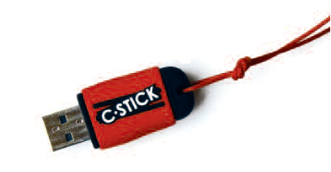
The portfolio was created on a USB flash drive, a very well known and attractive tool to young people that has several other advantages: firstly it can be permanently updated. Secondly it’s also a concrete and tangible tool young people can carry with them at any moment, unlike an e-portfolio on a website. However, the C-Stick portfolio on the USB flash drive is also connected via the internet to a server, in order to keep a backup of the data. It’s also linked to an administrative system by which tutors can send files and competence assessments to their pupils.

Since we wanted to create a portfolio apt for our target group, an important focus of attention throughout the development was to raise the level of accessibility by creating a very attractive and easy-reference interface and simple navigation structure and by using unsophisticated vocabulary.

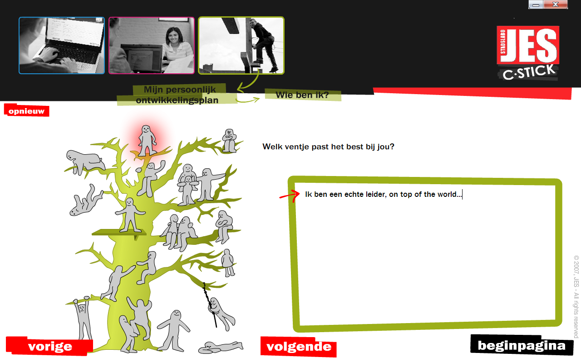
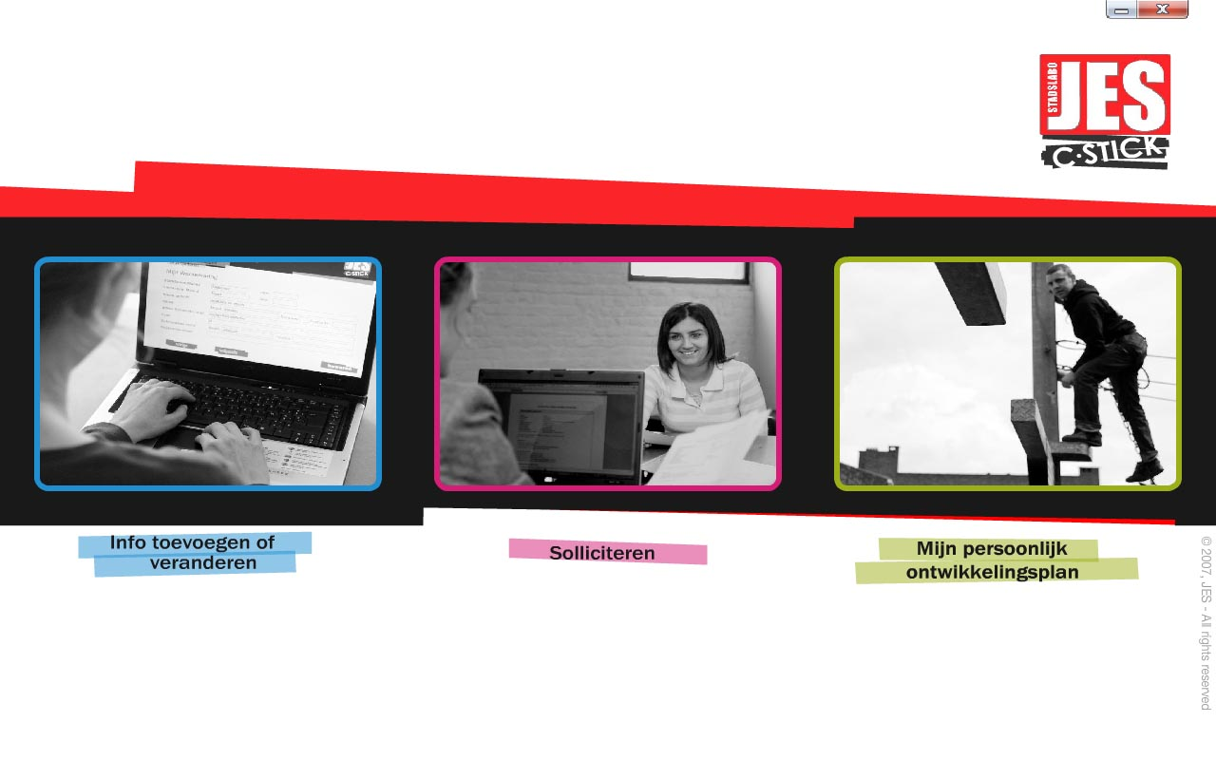

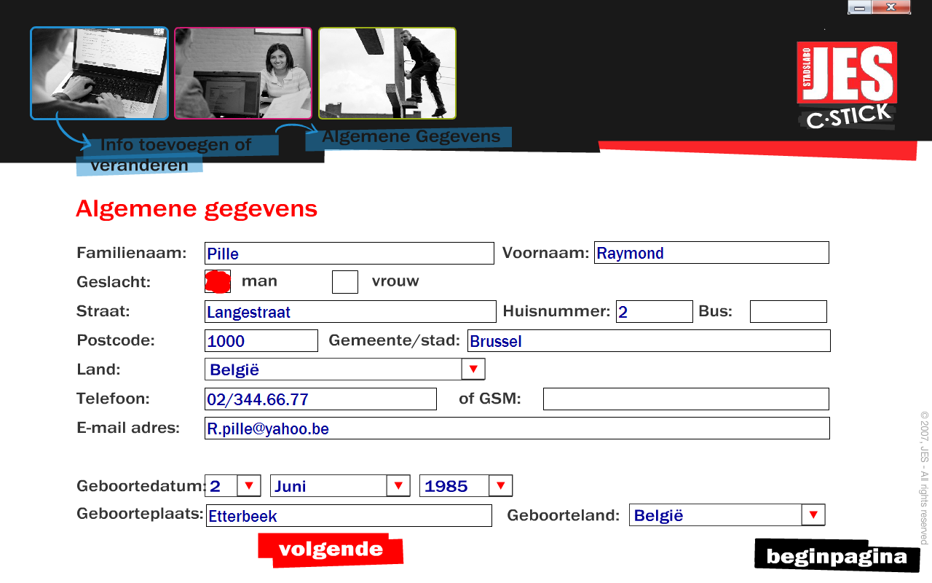
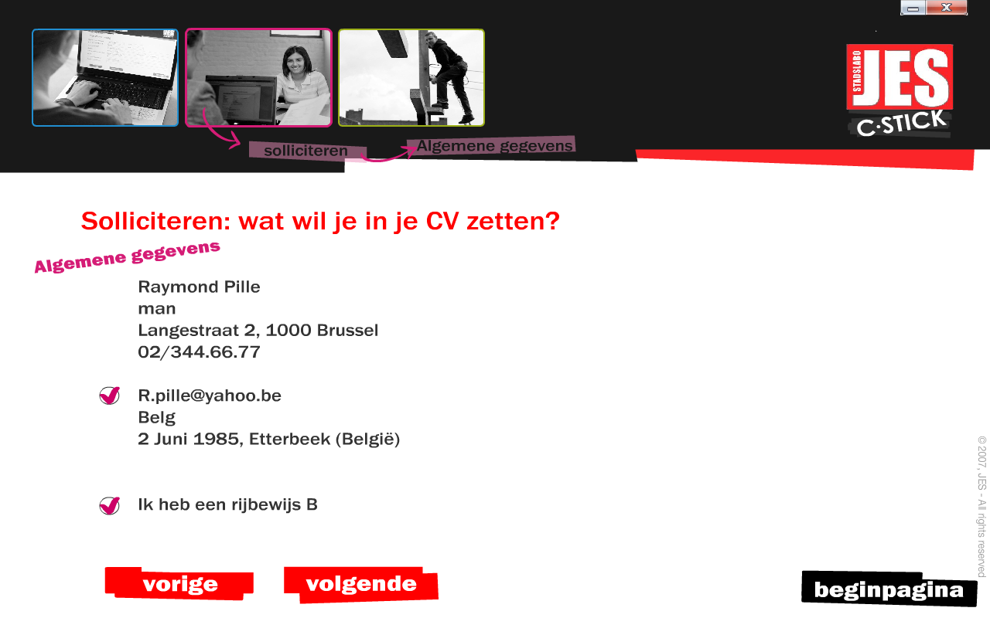

- Objectives
The C-Stick project is now moving from a very small-scaled pilot at JES to a more large-scaled implementation in some sections of the Flemish Employment Service (VDAB) and integration with their e-portfolio ‘Mijn Loopbaan (My Career)’. Other youth organisations and schools also started using the C-Stick. This evolution was not initially planned and grew from a bottom up process, but seems to set standards for future e-portfolio development in Flanders. It might as well be an interesting model for other countries or regions.
In this paper, we point out the main successes and difficulties we met throughout the process and present the model that was developed in Flanders.
- Summary of results
The C-Stick project originated from an ESF-call (European Social Fund). The most important strengths of the C-Stick project were some of the preliminaries that underpinned it:
- we wanted to create a portfolio that is accessible for a low-skilled target group
- we wanted to create a portfolio that coincides with existing terminology and data systems, which pushed us to establish cooperation with the Flemish Employment Service
- we wanted to create a portfolio that could be used in different settings: leisure time activities, training and job counselling.

At the end of the ESF-project, many other organisations were interested in using the C-Stick. This was certainly due to the growing awareness in schools and job counselling services on the need for tools that are accessible for a low-skilled target group and that focus on the identification and development of key competencies. Youth organisations on the other hand become aware of the importance of key competencies that are developed in youth work and are looking for tools to identify and recognise these competencies in an attractive way. Finally, to encourage lifelong learning and to facilitate transition, there is a need for tools that create a link between different learning environments (school, work, leisure time activities). The C-Stick is one of the first digital portfolios in Flanders that responds to this need.

Nevertheless, we faced some severe difficulties: technically the C-Stick system was not developed to be used by several organisations, on the juridical side there were no clear agreements with the software developers concerning ownership and finally there was no funding for further development and to cover staff costs.

These problems were solved thanks to funding from the Flemish Employment Service, own investments and successful negotiations with the software developing company.
In order to assure the continuity of the project, a centre was set up at JES to provide training and distribute C-Sticks to other organisations. Training is provided at commercial prices to cover the financial costs of the project.

In the mean time, technical research and development is carried out to accomplish data transfer between the C-Stick and the e-portfolio from the Flemish Employment Service ‘Mijn Loopbaan’. Probably this data transfer will be based on an xml-standard. This research should lead to a standard model for data transfer for future e-portfolios.

