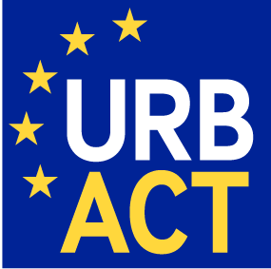

THE URBACT EUROPEAN PROGRAMME SECRETARIAT

IS LOOKING FOR A CAPITALISATION INTERN

The URBACT Programme
URBACT is a European programme that facilitates exchanges between cities to promote sustainable urban development. It enables cities to work together to build solutions to the big urban challenges they are facing today. It asserts that cities have a key role to play in tackling the increasingly complex issues in European societies. It helps cities to home in on trailblazing, pragmatic, long-term solutions that address the economic, social and environmental aspects of urban development. This programme also shares best practices and lessons learned from exchanges with all city professionals across Europe.

URBACT counts more than 500 cities in 29 countries and 7,000 local stakeholders.

Description of the internship
Under the responsibility of the Projects and Capitalisation Manager, you will contribute to the capitalisation activities of the URBACT II programme Secretariat:

Main tasks :

- Assisting the URBACT Secretariat in the organisation and follow up of activities related to workstreams and other capitalisation themes.

- proof-reading and content check of thematic publications (articles for the URBACT Tribune 2014 to be ready for the Open Days 2014, other possible workstream publications) and videos
- liaison with workstream coordinators
- liaison with external service providers (layout designers for publications, video team, others)
- drafting guidelines for service providers
- possible participation in workstream meetings around Europe

- Contribution to the organisation of URBACT events

- workstream event on 8 October 2014 in Brussels
- Open Days workshops 7-9 October 2014 in Brussels

Profile

- Graduate in any field in line with the proposed internship : political sciences, social sciences, European studies, etc;
- Excellent written and spoken English;
- Working knowledge of French;
- Very good planning skills, ability to work under pressure and to meet deadlines, ability to work independently;
- Very good written and verbal skills;
- Ability to work in an international environment;
- IT skills (web, MS Office, Excel, Word, etc.);
- Possibility to travel in Europe.

Additional Information

Duration and starting date
6 months, ideally starting 11th August 2014 ending February 2015

Internship conditions
Internship must take place within a training programme. An internship convention will be signed between URBACT, the school/University and the intern.
Internship allowance: 436,05 € per month + contribution to local transport.

Workplace
URBACT Secretariat
5, rue Pleyel 93283 Saint Denis cedex
(M° Carrefour Pleyel)

To apply
CV + cover letter (in English or in French) exclusively by email to:
t.picquart@urbact.eu and j.koutsomarkou@urbact.eu
Deadline: preferably before 18th July 2014

Candidates are invited to check with their universities that they are allowed to travel in Europe and to confirm this in their cover letter.

