Creative SpIN
Issue 3 – September 2014

 |  | 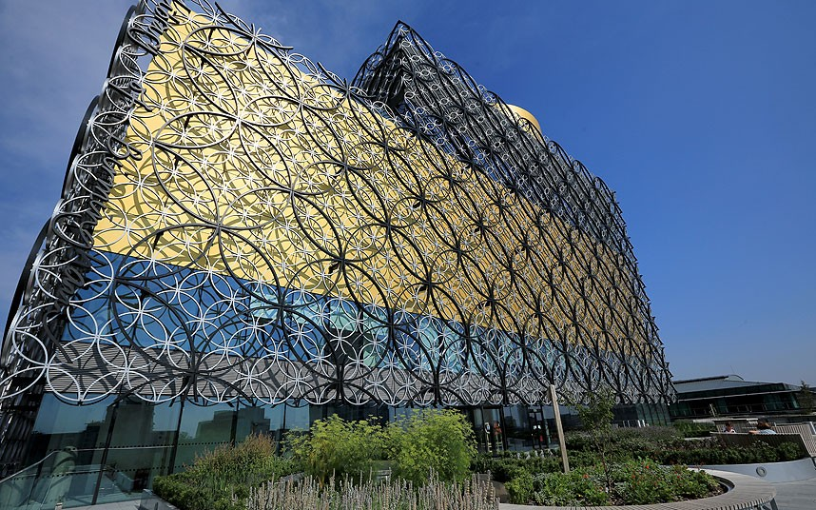


Creative SpIN– A creative way to support economic and social innovation (Issue 3)
An Article by Lead expert Philippe Kern

The new economy needs creative skills

We live in an era of great economic trans-formation. The contribution of the manufacturing sector to the European GDP, although still very significant, has recently declined with a gradual shift towards a service-based and digital economy.

The new trends in the economy are characterised by:

- Speed in production and consumption; (increasingly like fashion collections);

- Customisation/individualisation of the product offer requiring differentiation (often through better design, aesthetic, branding);

- Prevalence of intangible values (aesthetic, brands, design, meanings…) that are increasingly given as much importance as the functionality of the product: the cultural or creative value of a product becomes as important as its economic value;

- Experiential values that are considered increasingly important, both from the demand and the supply point of view;

- New social trends where people attach as much or more importance to sharing than to owning.

The new economy is often about creating the unexpected, the emotional. It is a “cultural economy” that fashions the commercial universe and which enables companies to stand out whether through branding, design, creative content or better user interface.
Today’s post-industrial economy is led by innovation, be it technological or non-technological. Whilst technological innovation leads to incredible productivity gains, non-technological innovation is of paramount importance both to improve productivity (e.g. process innovation) and to help companies differentiate themselves from competitors (e.g. new branding strategy or innovative products).

Although innovation intensity importantly varies across creative sub-sectors, non-technological innovation is a core competence of CCIs. Cultural and creative enterprises develop new ideas, products and services (often in small series and including customer-specific adaptations), work in flexible ways and are able to manage creative professionals to make the most of their inventiveness. Some sectors are also intensive users or, in some cases, early adopters of new technologies, thus playing a key role in the spreading of technological innovations (e.g. video games or publishing and the introduction of e-business practices).

Creative professionals’ and companies’ ability to think laterally, to “emotionalise” products and services, manage creativity or promote new uses of technologies is of paramount importance also for sectors outside the CCIs: they can support companies in search of new ideas and help them integrate innovative solutions across their value chain (from production to management).

Digital technologies play an important role in this intangible economy as they provide new forms of social exchanges and contribute significantly to new expressions of creativity. Cultural production (such as music, publishing and movies) makes new technologies more relevant to consumers, enables the development of new markets and contributes to digital literacy. The success of free and open-source software and services like Wikipedia are also trends that prefigure an economy which values sharing, exchanging knowledge and skills through collaborative platforms.

For industry, it is therefore becoming an imperative to meet and to create new kinds of demand that are not based merely on the functionality of a product but are instead rooted in individual and collective aspiration. In this new paradigm, marketing and services are as important as production. Creative people and artists are key because they develop the ideas, metaphors and messages which help to drive social networking and attractive collective experiences. A firm indeed needs more than an efficient manufacturing process, cost-control and a good technological base to remain competitive. It also requires a strong brand, motivated staff and a management that respects creativity and understands its process. It also needs the development of products and services that meet citizens’ expectations or that create these expectations.

Europe is particularly creative. Its creative professionals and industries - the envy of the world whether in design (fashion and luxury, industrial or graphic), architecture, advertising, animation, games, music and performing arts – offer a specific competitive advantage to Europe and put it in a unique market position compared to third countries such as US, China or Russia. The challenge for Europe is to make the best out of its creative diversity nourished by a patchwork of different cultures and improve its capacity to foster sustainable growth and jobs. For policy makers it is a question of better connecting creative capabilities to the environment of enterprises and universities to stimulate innovation.

What is spill-over?

Creative spill-over is a process by which the interactions between artists, creative professionals and industries and/or cultural organisations contribute to economic and/or social innovation in other sectors of the economy or society. The spill-over process takes place when creativity originating from culture and creative professionals and industries influences innovation in sectors where culture and creative professionals do not usually evolve.

Spill-over is about processes questioning rigidity and contesting the systematic, relying on the unpredictable or unwanted surprises born from the meeting of diverse skills and competences.

The benefits of interacting with CIs’ skills are well-known (from urban regeneration to social and business innovation). Here the focus will be on the role that CCIs can have in promoting innovation throughout the business value chain, for instance on:

- Products and services by combining new ideas, designs or expressive components such as symbols or aesthetics enabling companies to engage with customers’ sensibilities and create a unique relationship (e.g. cultural contents such as music or videos contribute to provide entertainment but also emotional experiences in relation to various (ICT) products and services).

- Human resources by enabling creativity to flourish in companies’ HR management strategies and translate it into better products and services (e.g. through design management, artistic interventions in companies or valorisation of creative functions).

- Process by contributing to creative production or delivery methods that directly involve and/or better take into account consumers’ needs in a “user-led” fashion (e.g. through the introduction of design-thinking techniques ), that rely on collaborative and decentralised work and entrust creative professionals (e.g. CEOs coming from the creative field in the executive board of technological companies), or that are based on the combination of multi-disciplinary competences (e.g. artists mingling with scientists open new R&D avenues ).

- Branding by adding a creative or artistic dimension as part of a brand’s distinctive identity (e.g. large fashion brands are linking up with artists, designers, crafts and art to give higher end (luxury) status to handbags, perfumes and catwalks; museums’ collections, art exhibitions or performances are sponsored by private companies as part of branding or Corporate Social Responsibility (CRS) strategies).

- Communication for instance to illustrate companies’ results and communication in a clearer or more appealing way either to investors or end users.

CCIs’ contribution to innovation

Creativity is fostered through a number of different creative skills that artists, creative professionals and industries, cultural operators and organisations can bring to other sectors of the economy to stimulate innovation. What are the creative skills capable of supporting innovation?

Artists and creative professionals have:
- A critical and disruptive vision of situation, space and time.
- The capacity to question “progress”.
- A capacity to give non-functional meanings.
- The ability to generate emotion.
- A capacity to transform society as drivers and leaders of changes (political, social).
- A “sharing attitude”: artists are first movers in the sharing economy.
- The capacity to create a fan base community (networking).
- An aptitude to work with people from different backgrounds and cultures.
- Ability to work in teams (at least in some sectors) and in a flexible and collaborative way.
- Ability to think laterally and express abstraction and symbolism: creative people are often brokers across disciplines whose skills and attitudes are conducive to creativity.

Cultural organisations and operators are able to:
- Attract and gather people and enable socialisation.
- Reinvent/rehabilitate (unused) places.
- Entertain and “stage” experiences whether individual or collective.
- Transmit culture and knowledge.
- Promote common history and cultural values.
- Educate.

Cultural and creative industries have the ability to:
- Entrust artists and creative professionals.
- Manage risk and understand failure.
- Create trends as critical brokers between creativity and the market.
- Generate experience and emotions whether individual or collective.
- Promote user-led and sustainability values and working practices.

CCIs are in the frontline of the experience and networked economy, where skills in entertainment, communication, networking, in staging experiences, in engaging/inspiring people, in managing risks are very much in demand.

Business literature and qualitative observations increasingly show that, beyond specific B2B relations (e.g. trade of creative services), CCIs’ competences are being integrated at different stages of the industrial value chain with positive effects on innovation and economic performance. For instance, it is estimated that firms with stronger B2B links with the creative industries are more innovative: firms that spend twice the average amount on creative inputs are 25% more likely to introduce product innovations. In the UK, every pound invested in design as part of the Design Leadership Project generated £4.12 net operating profit, £20 net turnover, £5.27 net exports. In Denmark, the Danish Design Council found that the gross revenues were around 22% higher for companies that invested in design than for those that didn’t. In Germany, two thirds of creative enterprises support their clients in the initial phase of innovation processes and significantly contribute to the development of new ideas and products. The survey also shows that creative firms are primarily asked to provide support services at the “top” of the client company’s innovation chain and, in addition to this, trigger innovative processes at its “bottom” (mainly in sales and marketing) .

Here are some examples on the contribution of CCIs to companies’ business development in:

- The ICT sector
Apple’s ability to create an emotional link with its technological objects, its iTunes service now generating EUR 4 billion on a quarterly basis and its recent recruitment of managers from the fashion industry are a clear sign of the added value that intangible values, cultural content (music) and creative professionals can bring to traditional engineering companies to make them stand out from the competition. Apple‘s pioneering work in injection moulding is considered as part science, part art .

- The retail environment
Nespresso has been successful at inventing the coffee shopping experience stepping into luxury retail environments.

- The transport sector
The “Virgin Atlantic in-flight entertainment experience” invented by music business entrepreneur Richard Branson has become the norm in the air-transport business. Hip and cool values are now an integral part of passengers’ transportation.

Dassault Aviation (French aircraft manufacturer of military, regional, and business jets) introduced a serious game as part of its HR strategy: it helps the company to teach the staff how to configure and conceive a plane in a much more secure and efficient way (several thousands of euros are saved per day).

- Manufacturing
Puma transformed itself from a shoe manufacturer to a fashion company in 2000 by integrating design into its production with a view to remain competitive with Adidas and Nike, the leading fashion brands in design and creative led innovation.

- Healthcare
The “Concept Room” - a prototype of a smart hospital room to increase the patients’ well-being developed in France – is the result of collaboration between a health cluster in Lille and local designers to invent the next generation of hospital rooms. The concept room born from an unexpected collaboration is now being commercialised.

Philippe Kern, Lead Expert-Urbact
1 September 2014


Creative SpIN is a network of 9 Cities, including Birmingham (Lead Partner) Rotterdam, Essen, Bologna, Tallinn, Mons, Kosice, Kortrijk and Obidos. The Cities will test how creative skills and competence can spillover to drive innovation in other key economic sectors. See: http://urbact.eu/fr/projects/innovation-creativity/creativespin/homepage/

URBACT is a European exchange and learning programme promoting sustainable urban development.
It enables cities to work together to develop solutions to major urban challenges, reaffirming the key role they play in facing increasingly complex societal challenges. It helps them to develop pragmatic solutions that are new and sustainable, and that integrate economic, social and environmental dimensions. It enables cities to share good practices and lessons learned with all professionals involved in urban policy throughout Europe. URBACT is 181 cities, 29 countries, and 5,000 active participants.
www.urbact.eu/project
Photographs: Library of Birmingham & Birmingham skyline

