Please fill in this form completely and send it by email to: f.hultenvan@obr.rotterdam.nl

Deadline for registration: 25 FEBRUARY 2011
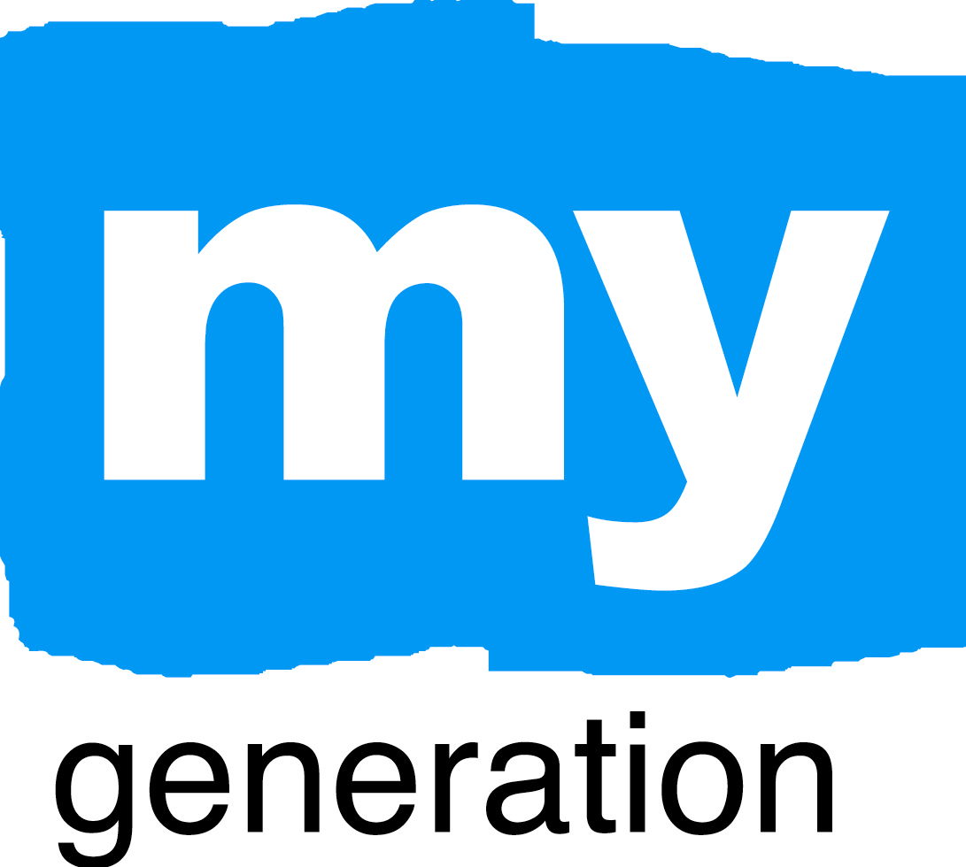
REGISTRATION FORM
MY GENERATION FINAL CONFERENCE
I will participate in the “MY GENERATION FINAL CONFERENCE” workshop on 1st April 2011

I will participate in the “MY GENERATION FINAL CONFERENCE” workshop on 1st April 2011

I will participate in the social programme:

Lunch
Vegetarian or other diet wishes:

I choose the following field visit (see description in ANNEX):
Please indicate your first and second choice. The maximum capacity for each field visit is 30 persons.

PEER coaching by and for youngsters in Antwerp
Food, fire and fun!

GENERATION A

TROEF: Making dreams come true
SHOOT!

I will participate in the “MY GENERATION FINAL CONFERENCE” workshop on 1st April 2011

Name
Function
Company
Address
ZIP Code
City
Country
Telephone number
Mobile phone number
Fax number
E-mail address

Hotel suggestions

Leonardo Hotel Antwerpen
De Keyserlei 59, Antwerp
+32 3 232 14 43

Leopold Hotel Antwerp
Quinten Matsijslaan 25, Antwerp
+32 3 231 15 15

ANNEX
Field visits:

- PEER coaching by and for youngsters in Antwerp
CDO North is an urban centre in Antwerp that provides an unique combination of on-the-job training and education to youngsters between 15 and 25 years old. Peer coaching is the core focus of the training programme. Annually, CDO North coaches 300 youngsters from 25 different ethnic backgrounds. Partner cities in the European League are involved in the programme, as well as the Council of Teachers in Antwerp, providing a forum for self-assessment and reflection. Visit the organisation, meet students and teachers and learn more about this unique programme!

- Food, fire and fun!
Social profit organisation Working and Learning Antwerp (WELA) coordinates projects for young people linking work and training in different sectors like metal working, carpentry and healthcare. In cooperation with the Fire department of the city of Antwerp, the organisation runs a restaurant where young people get on-the-job training. Visit the restaurant and hear more about this programme!

- GENERATION A
The city of Antwerp is proud to be European Youth Capital 2011! In this visit, you will meet the whole Communication Team, which is composed of six enthusiastic youngsters from the city of Antwerp who are responsible for all communication activities. The team is coached by a professional agency. Meet the team and find out everything you want to know about Antwerp Youth Capital 2011!

- TROEF: Making dreams come true
With the TROEF programme, Antwerp offers youngsters in the city the opportunity to make their dreams come true and to make Antwerp a better place for young people. Each year, the three best ideas receive support from the city. Visit two of these projects and meet the youngsters that are in charge!

- SHOOT!
SHOOT is the ultimate combination between street soccer and youth culture. This year, for the first time SHOOT is going European by the participation of youth soccer teams from all over Europe. Get a taste of the SHOOT experience and discover the Antwerp style of youth work in an active way by participating in one of the workshops or enjoy the atmosphere and watch the street soccer games!

