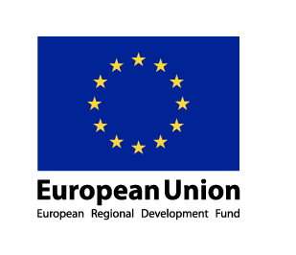

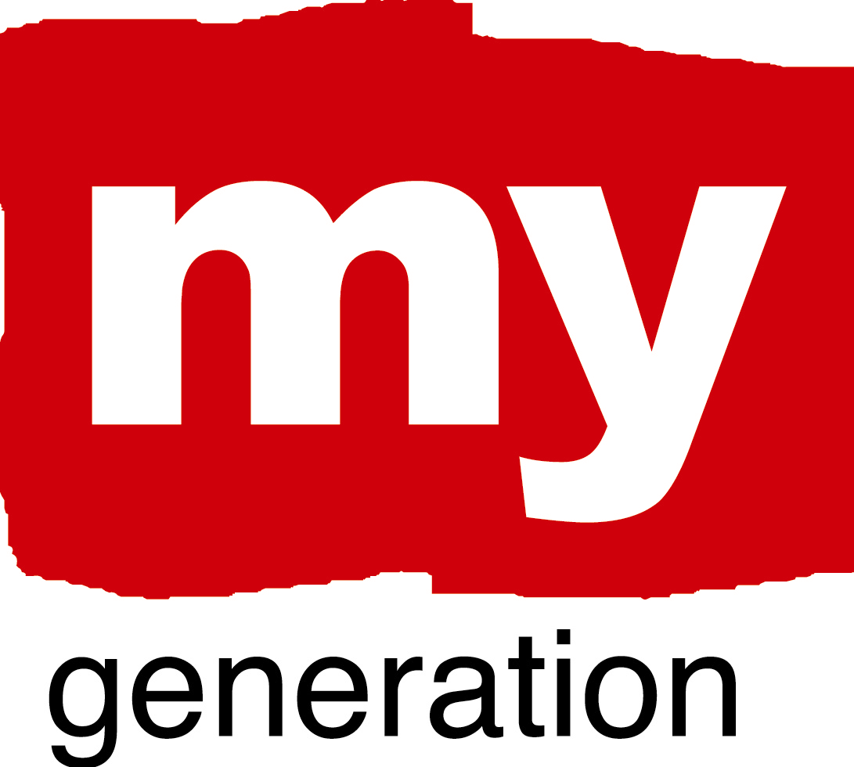
Gdansk, July 2010


Progress Report - MY GENERATION Gdansk

January – June 2010

I Update on work progress

City: Gdansk

Name of your LAP: Youth Carries Up Gdansk, Młodzież Dźwiga Gdańsk

What is your LAP about?
Its focusing on the role of youth in the City. The role of young people in the City’s policy, City’s and its Units actions, the role in the civil society development and the youth engagement into public life.
Gdansk LAP shows also the relations between adult and younger part of the City. Shows opinion of younger part of local society about their situation, possibilities and general relations with parents, teachers, local authorities and politicians.
Another aspect touched on the document is a list of existing and possible activities devoted to youngsters activisation. In the Assumption it should be the place where all good practices and examples of youth engagement are showed and valued.
As a task to develop, thanks to the LAP, is a creation of the document being a tool to create a new reality in Gdansk. The document showing into the detail how the youth forum should work, what its tasks should be, how to compose a representation of all the different youngsters groups and how should represent the younger part of Gdansk.
The Gdansk LAP wants to show also the possible scenarios of youth policy development.

What are your objectives?
We want to create a youth as an equal part of society. The group being a creator of reality into the City, being a responsible for their local society and active in private and public life.
Youngsters end especially their positive actions should be also promoted and visible in all possible local sources of information. Should be appreciated and visible as well as their voice.
Those two objectives shows that youngsters with their activities should have stronger support and should be more visible in a public life. That requires the change in the local authorities approach to Youth from the one who is telling how should be to the one who is listening.

A brief update of your MY GENERATION work progress since Riga workshop in the space below:

Where has your work concentrated since Riga-workshop?
After the half of year of meeting only with youngsters representatives we have focused our work on lobbying and meeting with representatives of political level in the City. As a apogee of this work was a meeting with Gdansk Vice Mayor Ewa Kamińska and Mayor of Gdansk Paweł Adamowicz. Meeting were devoted to the project itself and also the LAP and youth strategy in general in Gdansk and all possible ways of this issues development in the close future.
We were also developing a network of NGOs and city institutions working for and with youth. Every month of project open a new source of information about activates for youngsters and gives opportunities to connect them with each other and with youth representatives.
The important part of our work was focusing on Gdansk workshop preparation. It required not only an organisational actions but also a meetings with co-hosts, persons declared to show the real situation of youth in the City and particular actions focusing on younger part of local society.

Where have you made best and most interesting progress?
The meeting with a Mayor of Gdansk and his personal words of support and engagement into the youth forum establishing was the vital point of first months of 2010.
After this meeting we have made a decision of starting a LAP actions and planning the youth forum and small grants fund for youngsters project. It gave us also a vision of possible ways of youth policy development in the City.

What (possible) obstacles, problems, questions?
The main problem might be a financial support form the City budgete after the My Generation project ending. It might be also hard to keep the people engagement into the youth policy creation without at least NGOs intrest.
For the LAP, youth policy and youth forum implementation there is a need of increassing a number of office workers dealing with this issues.

How well has your Local Support Group functioned?
During last half of year we didn’t organize any LSG meeting – instead of this we have organized meetings with its particular members and especially politicians responsible for youth and social issues.

Where is your work with the Local Action Plan at the moment?
After the first draft prepared at the end of 2009 we have focused on:
- describing situation of youth in the city,
- describing city approach to youth issues, NGOs and youth,
- showing how many activities in different types is at the moment dedicated to youth,
- particular form of youth forum to be planned and implemented,
- and probable directions of LAP as a youth strategy development.
September 2010
- The LAP draft is written
- Analysis – financial possibilities for youth projects implementation in Gdansk
- Arrangements and decisions by politicians
- Meetings with younger and wider versions of ULSG
Future actions
- Youth forum kick-off
- First edition of small grants
- LAP to be written
- Meeting with political authorities about LAP implementation

II Self-evaluation using a scale

1. EMPOWERMENT: Empower young people to act by themselves, to think independently, to make choices, to create and co-create, to be responsible and to stand up for their rights.

1 = Young remain in a passive role, as a traditional “target group”
2= Small active role established for the young, still a “target group”
3 = The young participate rather actively here and there
4 = The young are actively engaged in the activities
5 = Real, very active, self generated and sustainable participation and co-creation with the young has been established

Our overall rating was: 2
The ratings varied from 1 to 3
What were your main conclusions and suggestions of improvement:

There is a problem rather on the side of City understanding and seeing youth as a equal part of society than on the side of youth. Youngsters are active and often looking for a possible actions but also often only demanding and behaving in a passive way. It is because there is a lack of faith that youth voice is important and powerful.

2. BUILDING TRUST AND NEW CONNECTIONS: Strengthen social relations, improving confidence and trust as well as communication (between the young, local communities, education and business)

1 = No new connections and level of trust has been established
2= A few new connections and some new trust has been established here and there
3 = Medium level of new connections and trust has been established
4 = A good level of new connections and trust has been established
5 = A very good and sustainable level of new connections and trust has been established

Our overall rating was: 3,4
The ratings varied from 2 to 5
What were your main conclusions and suggestions of improvement:

There is a strong wave of local societies activisation, via non-governmental organisation and youngster. They are focusing on building social relations and networks for the common good and local needs. The most important is increase of positive relations between youth and local civil society organisations.

3. CHALLENGE PREVAILING STRUCTURES AND ACTION: Contribute to change of social structures, “sending a message”, tackling the structural causes of exclusion in order to prevent young people loosing faith and opting out and being exluded

1 = Prevailing structures and action have not been challenged at all, no “message has been sent”
2= Prevailing structures and action have been challenged a little bit, here and there, “a small message has been sent”
3 = Prevailing structures and action have been challenged in a meaningful way, , “a meaningful message has been sent”
4 = Prevailing structures and action have been challenged in a very meaningful way, , “a clear message has been sent – and it has been heard”
5 = Prevailing structures and action have been challenged very clearly, “a very clear message has been sent – which has led to renewals”

Our overall rating was: 2
The ratings varied from 1 to 3
What were your main conclusions and suggestions of improvement:

There is a strong structure that is hard to challenge and especially for the youngsters themselves and their representatives – NGOs and schools structures. There is a need of development of any youth official political body being important for a City Council and other authorities.

4. PROMOTING COORDINATION: Promote the cooperation of different actors by adopting integrated and holistic approaches

1 = Actors and approaches remain very fragmented
2= A little integration between actors and approaches has been established
3 = Some meaningful integration has been established
4 = A good level of integration has been established
5 = A very good and sustainable level of integration has been established

Our overall rating was: 1,5
The ratings varied from 1 to 2
What were your main conclusions and suggestions of improvement:

There exist only small signs of youth policy coordination and the ratings nr 2 were given only because of this – My Generation attempts and potential.

5. RENEW YOUR “PRODUCT ECOLOGY”: renewing the understanding of knowledge and skills to capture better also informal, “experience based” knowledge, and use creative ways of action and co-creation with the young, in order to communicate better, and also realise new potentials of the Web and multi-media.

1 = No new ways of communicating with and recognising capabilities of young have been established
2= A few new ways of communicating with and recognising capabilities of young have been established
3 = Quite a few new ways of communicating with and recognising capabilities of young have been established
4 = A good level of new ways of communicating with and recognising capabilities of young have been established
5 = A very good and sustainable level of new ways of communicating with and recognising capabilities of young have been established

Our overall rating was: 3
The ratings varied from 2 to 5
What were your main conclusions and suggestions of improvement:

There exist a new ways of communication ant there is not a problem of targeting and hitting the target – hitting the youth attention but there is a problem of value of respond and its effectiveness.

II Self-evaluation on a “spidergram”

Wojciech Dąbrowski
City Hall of Gdańsk
Social Affairs Department
+ 48 / 58 323 67 17
w.dabrowski@gdansk.gda.pl

