
Antwerp (1)
Youth competence centres
What is your LAP about?
To develop a way to increase the performance of the Youth Competence Centres and to integrate them more in the entire youth policy. In addition, we will have to find a way to make the YCCs solve problems in Antwerp concerning education, spare time and employment.

What are your objectives?
To further develop the youth competence centres and make them give a response on spare time issues, education issues and unemployment issues.

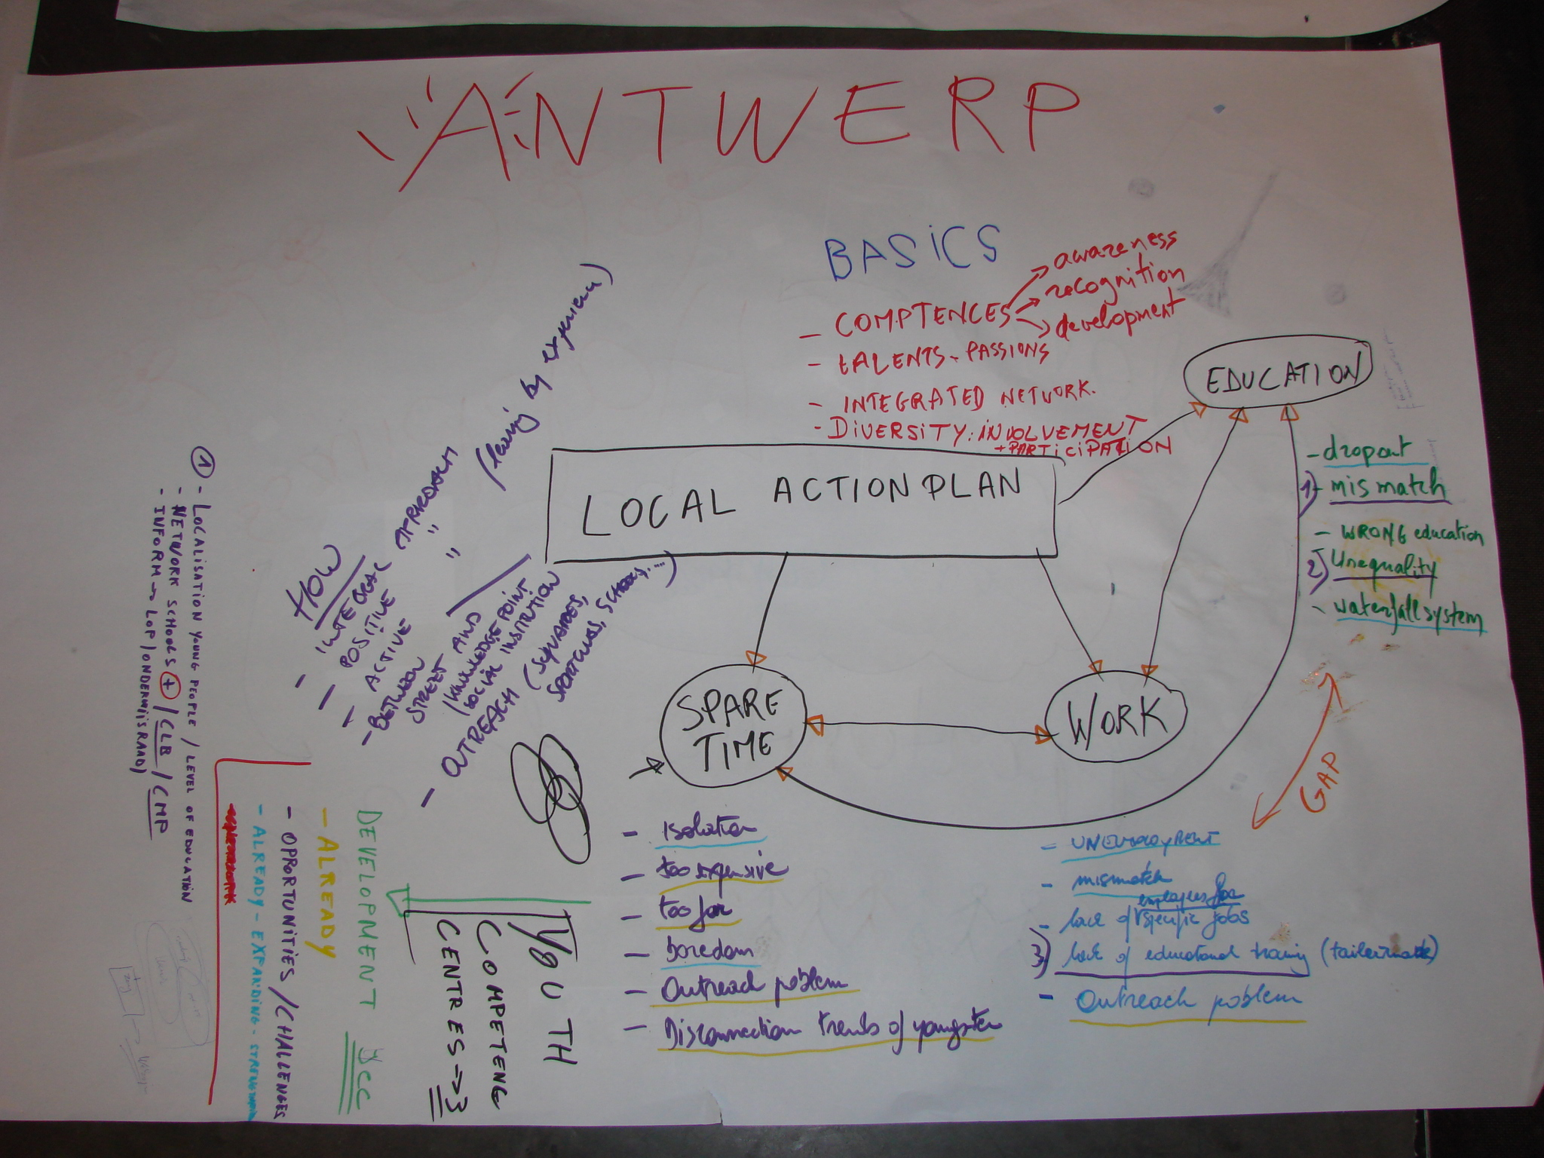
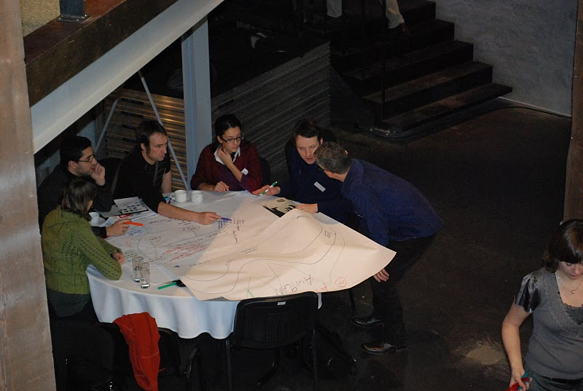

Antwerp (2)
Youth competence centres

Where has your work concentrated since Riga-workshop?
Since Riga we have tried to further develop the ycc’s, starting with expanding the local support group. The involvement of the department of education had to be intensified. When we observed the YCC’s we realized that there are a lot of opportunities for the Ycc’s concerning education. Education is one of the main problems of youth in Antwerp and the Ycc’s have a very important role to play. To do that the involvement of the education department of the city is very important, but not so easy. Besides that we have been trying to expand the LSG so that we have different stakeholders.

Where have you made best and most interesting progress?
Now there is a representative of the education department who is a basic partner of the Ycc’s.

What (possible) obstacles, problems, questions?
The obstacles are always those concerning employees and funds. To develop the education part of the Ycc’s we need funds and workers and that is not so easy.

How well has your Local Support Group functioned?
The Local support group functioned well, and we work together in the further development of the Ycc’s.

Where is your work with the Local Action Plan at the moment?
At this moment we have a mind map, we are expanding the LSP and we are looking for a consultant to help us develop the LAP.
Antwerp (3)

Youth competence centres

September 2010 - Since the participation in My Generation we have tried to further develop the ycc’s, starting with expanding the local support group. The involvement of the department of education had to be intensified. When we observed the YCC’s we realized that there are a lot of opportunities for the Ycc’s concerning education. Education is one of the main problems of youth in Antwerp and the Ycc’s have a very important role to play. To do that the involvement of the education department of the city is very important, but not so easy. Besides that we have been trying to expand the LSG with different experts and organisations so that we have different stakeholders. We hired a processor to guide the LSG while developing a local action plan.
In September we had the first meeting with the broad local support group and the processor. We had a brainstorm with different experts concerning the area’s employment, education, youth and spare time.
In the future:
The next step will be a selection of a few very important and urgent actions. Then we will try to further develop these actions, starting with the actions that can be implemented easily and then the actions that are very innovative and effective but need more funds and engagements from the different partners. Obviously there will be more resistance for the last actions. We have to counter that first, before starting with implementing these actions.

Antwerp (4)

Youth competence centres

SELF EVALUATION-SPIDERGRAM

EMPOWERMENT: 3
The youth is not very involved in Antwerp. There are a few youngsters who are active but the main problem is that the biggest group does not feel to be very involved in the society of Antwerp. The Ycc’s work very intensively around competences and try to give the feeling to the youngsters that the centre is their centre. In addition to this the main goal of the Ycc’s, we want to work around the competence of youngsters and to give them self-confidence. Conclusion is that the Ycc’s work a lot around involvement of the young, but the city in general could make some more efforts.

BUILDING TRUST AND NEW CONNECTIONS: 3
The Ycc’s work already very hard around confidence. We try to improve the contact between the young and the city, but still we can do more. By involving employers and other stakeholders in the local support group we try to improve the relations and the communication between the young and business, the young and the neighbourhood, etc

CHALLENGE PREVAILING STRUCTURES AND ACTION: 2
The ycc’s prevent crime by offering the young a better self image and a better future, but still we can do a lot more. The most important area is education. If we want to prevent exclusion then we have to prevent the drop-out at school. So in the future we have the intention to develop further the
Antwerp (5)

Youth competence centres

educational branch of the ycc’s. The ycc’s could help the youngsters a lot with their homework and other educational issues. But the tools that are developed in the ycc’s to involve and to motivate youngsters could also be used in the schools.

PROMOTING COORDINATION: 4
The Ycc’s starts from a holistic view. That is the reason why we operate within three areas: spare time, competences and work. While the young come to the ycc’s to enjoy themselves, we try to work in an informal way on their competences. We realise that youngsters are not only interested in spare time, but are often primarily interested in work, so we try to work on that area too.

RENEW “PRODUCT ECOLOGY”: 4
In the Ycc’s we use the C-stick. With the C-stick and My digital me the young have the opportunity to recognize their competences. The C-stick is an innovative digital portfolio. The C-Stick is a central database where young people can gather and store all kinds of relevant information, it provides them with a framework for personal development plans and it contains a tool to create adjusted CVs in a very quick and easy way. With the C-Stick the main focus is on the identification and development of key competencies.

