

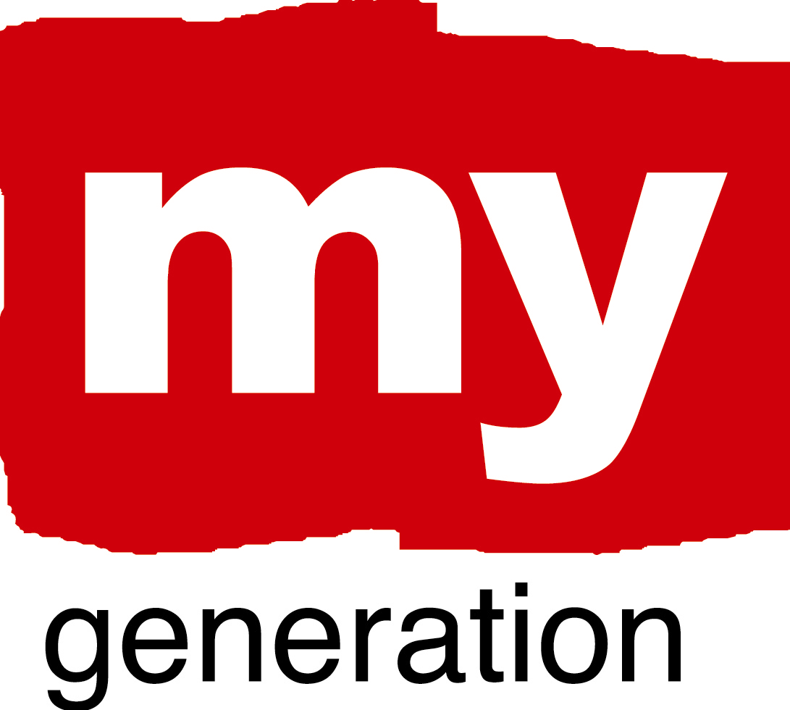

MY GENERATION, 2nd EDUCATION & EMPLOYMENT WORKSHOP,
28th September – 1st October 2010, Valencia

DRAFT PROGRAMME

REMARK: When planning your trip, please make sure you do not need to leave the meeting before the real end of the workshop (Friday 1 October, 13:00)!

Tuesday, 28th September 2010

 | ARRIVAL OF PARTICIPANTS
18:00-19:30 | Preparation meeting only for experts, facillitators & presenters
20:00 | Everybody gathers at lobby before going to the restaurant
20:30 | Informal welcome dinner. Restaurant to be announced.

Wednesday, 29th September 2010: A New Generation of Entrepeneurship

Venue: “Cristales del Ayuntamiento” of Valencia
Youth Delegation
Casal d’Esplai

Content of the day will be guided through 3 main questions

- How to stimulate and support (a new generation of) entrepeneurship as a city/school/company/individual?
- Is entrepeneurship only a job or also a skill?
- The added value of social entrepeneurship / social enterprises?

08:30 | Departure from the hotel by bus to venue
 | Registration, accreditations & coffee
 | Welcome and introduction by the Youth Councillor Beatriz Simón Castellets
 | Programme introduction & Ice breaker
First assignment + Coffee Break.
What is My Generation? This question will be given to the participants to think and talk about during the coffee break.

 | My Generation project work on Entrepreneurship
Lunch
Location: building cafeteria

My Generation project work on Entrepreneurship,

Parallel or plenair (to be decided): exploring the connection between Entrepreneurship and the Operational Programmes of the Managing Authorities (exploring good practice examples)

 | Coffee break
Support for entrepreneurs

Including Proposal of AJE Valencia:
Support for entrepeneurs, school visit AJE. AJE explains how they work in schools (testimonials from entrepeneurs, the business community)

17:00 | Back to hotel. Free time.
 | Everybody gathers at lobby before going to the restaurant
20:30 | DINNER

Thursday, 30th September 2010: Transition to working life

Venue: to be decided

Content of the day will be guided through 2 main questions

- How to bridge the gaps in the actual knowlegde about the labour market at the city/school/individual?
- How to improve the connection with and transition to the labourmarket?

08:30 | Departure from the hotel by bus to venue
 | Official reception in the hall `Cristales del Ayuntamiento`of Valencia
 | Transfer by bus to the venue
introduction of today’s theme “school  job” + Coffee Break
food for thought will be given to the participants to think and talk about during coffee break.
 | My Generation project work on the transition to the labour market
 | Coffe Break
 | My Generation project work on the transition to to working life
 | Lunch
My Generation project work on the transition to working life

Parallel or plenair (to be decided): exploring the connection between the ‘Transition to working life’’ theme and the Operational Programmes of the Managing Authorities (exploring good practice examples)

 | Preparation for parallel visits
 | Parallel Study Visits
17:30 | Back to hotel. Free time.
 | Everybody gathers at lobby before going to the restaurant
20:30 | Dinner

Friday, 1 October 2010:

Venue: Youth Delegation
Calle Campo Amor, Valencia

09:30 | Departure from the hotel by bus to the Youth Delegation Calle Campo Amor
 | My Generation project work on the Coordination Theme and Local Action Plan
 | Coffee break
 | My Generation project work on the Coordination Theme and Local Action Plan
13:00 | Goodbye Lunch

