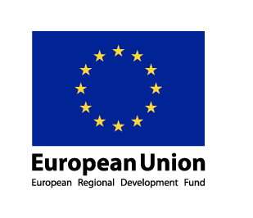
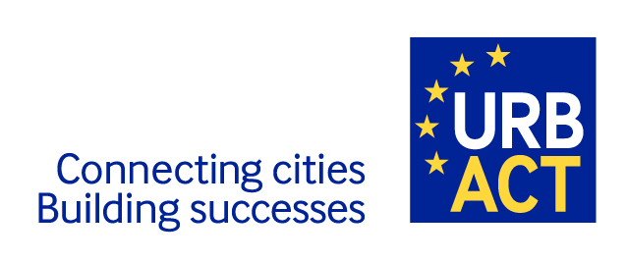
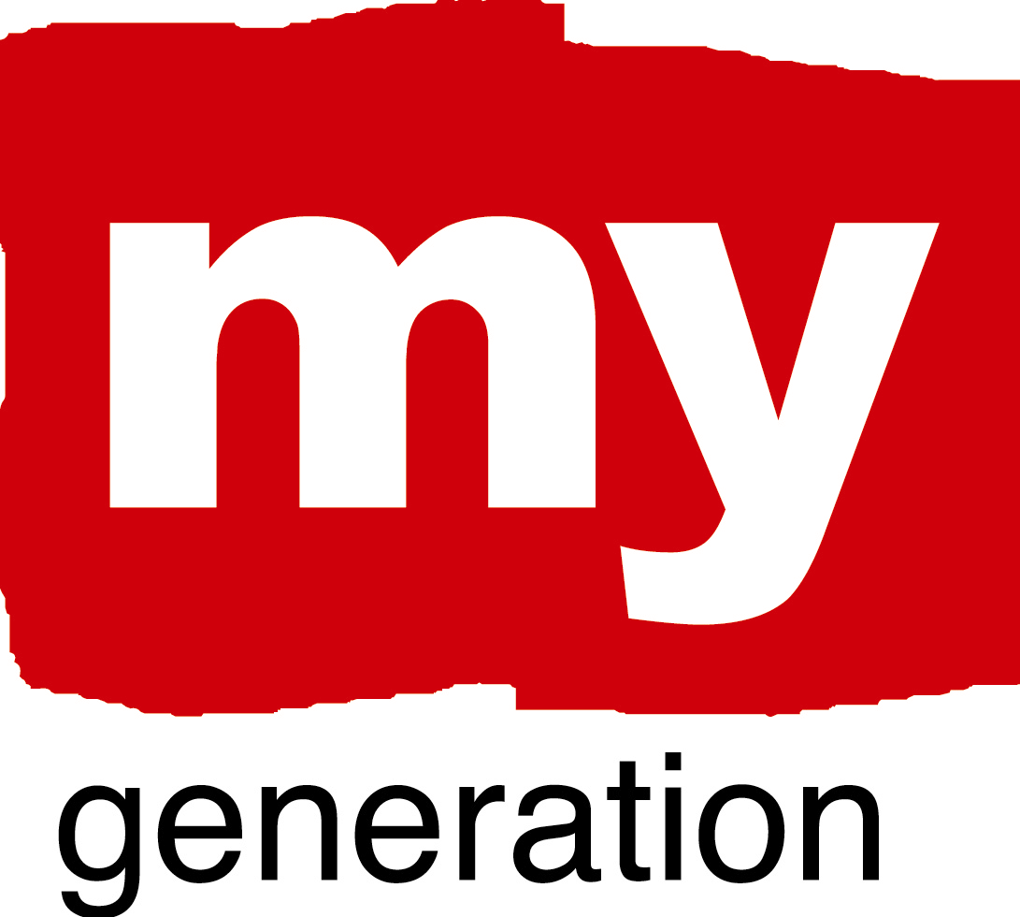

Friday 28th May 2010: New Generation of Youth Counselling
Venue: Muzyczna Cultural Centre, Gdansk
What will be the legacy of My Generation in each city? We want to make sure that involvement in the network has made a difference to all participants and this will be our focus in the final part of the Gdansk workshop.
We have identified the various good practices as a kind of “continuum” in a My Generation Landscape. On the left there are activities on Outreach, the first contacts with young people outside positive activity, then there are, moving to the right different stages of activity ranging from
- small group activities for self-esteem building
- youth house spaces for engagement and creative activities
- community schools, guidance and ways of tapping into informal knowledge and skills
- getting to know about working life and setting up business
- work practice and transitions to working life
This is a journey from initial “puzzlement” to self-reliance via various forms of positive and creative activity, supported by guidance. The transition points are particularly critical, because otherwise good results at some stage can break down if there are not further positive alternatives. Also, the engagement with the young must be tailored to their particular situation.
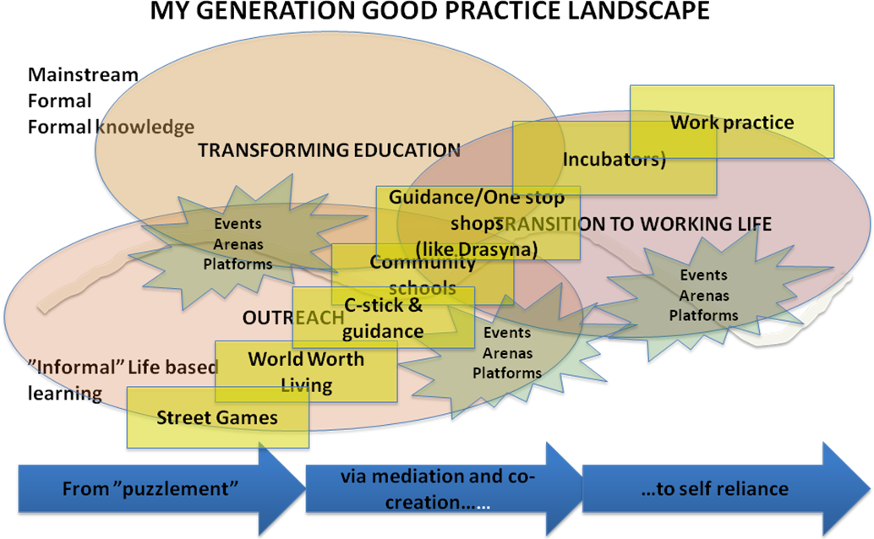

From the city case studies it is clear that Information, Advice and Guidance - Youth Counselling for short - is a core part of most cities’ offer to young people. We can see this in a number of ways: embedded in cities’ outreach activity (eg in Birmingham’s World Worth Living), linked to ICT tools (e.g. Antwerp’s C-stick) and in new models of area-based services (e.g. Patras’s DRASYNA, Rotterdam Community Schools).
Nobody yet has the perfect coverage of good practices of youth engagement and co-creation of the entire landscape. And all of our existing good practice can be challenged further.
Table 1: The building-blocks and quick self assessment for a New generation of Youth Counselling
Building blocks | What does it contain | Do we something have this? Where are we strong – where weak?  Where do we want to improve/ learn?
1. Activities in the streets and “at the doorsteps” like Birmingham “Street Games” or using sports as an outreach vehicle like in Glasgow | Using sports, art and dance professional networks in connection to voluntary and community work to really reach out for the young – and connecting this to all the below
2. Small-group activities for identity- and self-esteem building like World Worth Living | Working with very sensitive and “hands-on” guidance to reach self-esteem and confidence to move on to further activities – and connecting this to all below
3. New ways of recognizing informal skills and knowledge like “C-stick” and guidance in Antwerp | Using the new digital, Internet, multi- and social media to the full to make it possible for the young to demonstrate and develop their skills – and connecting this to all the other activities here
4. Providing information on education, careers, business and jobs like Guidance in Patras, and like in many other cities | Offering information and personal one-to-one or small group guidance in voluntary centres, in secondary schools, vocational schools and in higher education, and in job-centres – and connecting this to all the activities here

5. Community events and activities, like voluntary and free-time engagements in Riga and Gdansk | Using voluntary and free-time activities and events for creative activities and connecting them in various ways to all the activities here
6. Youth Spaces for creative activities and engagement like various “Youth Houses” in cities or the “Green House” in Malmö | Providing spaces for the young, run by the young, and providing connections, professional advice and ideas for creative activities – and connecting all these to all the others here
7. Business incubators and work practice, like young entrepreneur incubators in Gothenburg, or connections to business and entrepreneurship in Valencia | Connecting youth activities to the business community, working life and entrepreneurial careers – and connecting business to all the other activities here
8. “Joker block” – something good you have, which is not mentioned here
9. “Black box” – something that is missing and should be created

In this session we will focus on how each city can further develop and improve its way of working with young people. Our aim is to transform relationships, to improve delivery models and to get better results for and with young people. We want you to make an assessment what you have, and where you want to improve.
For this final session we will be asking you to undertake 3 roles:
- Come prepared to talk about the 3 biggest strengths of your city’s work with young people and the 3 areas where you still have most progress to make. Use the ‘building blocks’ above to describe these strengths and weaknesses. For example, your strengths might be in relation to Building block 1 (Street/outreach activity) or Block 3 (new ways to acknowledge informal skills). In terms of improvement you might feel that you are weaker around Block 7 (Business incubation/entrepreneurship). We want you to come and tell us…
- Come prepared to assume the role of ‘critical friend’ where you will listen to other cities and challenge them to make progress in key areas. We know one another pretty well now and we’re getting a good idea of who is stronger in this area and who is stronger in that. It’s always helpful to get honest feedback from a trusted friend – so we will all have a role to play in challenging other cities and suggesting where they can go further.
- Work with colleagues from your city to identify development priorities that you will undertake through your local partnership before we next meet in Valencia. This is the ‘so what?’ part of the session. Having thought about our city’s strengths and weaknesses, and having heard the constructive criticism of our peers, where is each city going to focus its attention on making things work better. Again, it’s your call!
The following page sets out the outline plan for this session, but if you need any further details in advance just get in touch. Look forward to seeing you in Gdansk ☺
Eddy eddy@eaconsultants.com 0044 1904 767321 or 0044 7710 473 712

0900-0930 | Energiser, introduction and explanation  Quick recap on Building Blocks and Landscape and getting reactions from the group  Moderator: Ed
0930-1030 | Part 1: New generation of youth counselling  Antwerp colleagues explain strengths and weaknesses of their youth counselling model - they position their 3 ‘strengths’ and ‘weaknesses’ written on cards (we’ll provide) on the landscape map. Other cities interrogate and challenge.  Antwerp gives a 10 minute presentation of the “Antwerp experience”, and then questions and comments for Antwerp  Moderator: Ed  Notes by: Ulf
1030-1045 | Coffee
1045-1130 | Part 2: Sharing and cities identifying priorities  Break into 3 groups as follows:  Group 1: Gothenburg, Rotterdam & Warsaw  Moderator: Ulf  Notes: tbc (Helen?)  Group 2: Valencia, Gdansk, Patras and Tirgu Mures  Moderator: Bob  Notes: (Taru?)  Group 3: Birmingham, Antwerp, Glasgow and Riga  Moderator: Ed  Notes: tbc (Nikki?)  Each city repeats the Antwerp process. Place the strengths and weakness cards on the landscape and give short explanation. Other cities play role of critical friend.  Short opportunity to circulate the room and see the other landscape maps over coffee.
1130-1145 | Coffee
1145-1300 | Part 3: Next steps  Each city’s participants come together to review key messages and actions they will take forward to improve their city’s youth counselling service. What are the actions? Who will lead on them? Who needs to help? Can other MG cities help? What are the timescales?  Short feedback – headline actions  Next steps – plans for Valencia

