

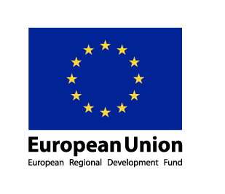

Pre-Gdansk Update and Self-evaluation Task for MY GENERATION partners

All partners are asked to
( a) give a brief update of their MY GENERATION work progress, i.e. how their work towards a Local Action Plan is progressing. The slot and questions to give the update is below.
(b) to perform a self-evaluation of their MY GENERATION work until now against a set of self-evaluation criteria given below.
The self-evaluation criteria will also be used, in flexible ways, in our discussions in Gdansk as basis of a “peer review”.
The update and self-evaluation should be completed by 7 May and sent to Cleo, Esther, Bob, Ed and Ulf. (c.pouw@obr.rotterdam.nl, e.sprangers@obr.rotterdam.nl, robert.arnkil@armas.fi, eddy@eaconsultants.com, ulf@europeanminds.com )

I Update on work progress

Foreach partner we will make a big poster of the creative work for your LAP developed in Riga (the photo’s of your LAP result in Riga also available on our website, under “Partners”).
To make it possible for partners to understand the work of the others we will also print some basic information for each city on a big poster sheet. This will be on the walls in the workshop room. Therefore, please complete the short list below (you can use the information from your second progress report, prepared by the end of 2009):
City:
Name of your LAP:
What is your LAP about?

What are your objectives?
(this will also be printed on a big poster, and put on the walls of the workshop room)

To make a preparation report, we also need you to complete the questions below.
Please give a brief update of your MY GENERATION work progress since Riga workshop in the space below:

Where has your work concentrated since Riga-workshop?

Where have you made best and most interesting progress?

What (possible) obstacles, problems, questions?

How well has your Local Support Group functioned?

Where is your work with the Local Action Plan at the moment?

II Self evaluation

On Thursday 27 May we will ask all partners to give a short presentation of their LAP progress (without Powerpoint). As part of this presentation we will ask you to explain (on the spot) the outcome of your Self evaluation (in a Spidergram).
This Spiderman can be prepared with this Self Evaluation!
We will make sure to bring big posters with your Spidergrams. These need to be explained during your short city presentation on Thursday 27 May.

The self-evaluation of your MY GENERATION work so far is done on five key dimensions of MY GENERATION: empowerment of the young, building trust and new connections, challenging prevailing structures and action, promoting coordination and renewing your product ecology. By “MY GENERATION” work we mean what you have been doing under the “umbrella” of MY GENERATION, working towards a Local Action Plan.
The self-evaluation should be done via a discussion in your project team and the Local Support Group, in a way you deem appropriate. The main point here is not the self-evaluation per se, but the discussion you have while making this discussion, and the conclusions you make on the basis of it.
The self-evaluation should be done in a flexible, honest and mutually open way. A good way of doing it is first familiarising yourselves with the dimensions, and then having someone as a facilitator for the discussion and the summary.
There is overlap in the dimensions, and they can be also interpreted in somewhat different ways. This is quite OK, because self-evaluation is intended to prompt reflection. It is not rocket-science. Do not get stuck with arguments about details. The purpose here is to get a rough picture where you have made progress, and where the challenges are. If you come up with an extra dimension or two you want to add, fine, go for it!
The dimensions for self-evaluation are the following:

II Self-evaluation dimensions

1. EMPOWERMENT OF YOUNG: Empower young people to act by themselves, to think independently, to make choices, to create and co-create, to be responsible and to stand up for their rights.

2. BUILDING TRUST AND NEW CONNECTIONS: Strengthen social relations, improving confidence and trust as well as communication (between the young, local communities, education and business)

3. CHALLENGING PREVAILING STRUCTURES AND ACTION: Contribute to change of social structures, tackling the structural causes of exclusion in order to prevent young people loosing faith, opting out and being excluded

4. PROMOTING COORDINATION: Promote the cooperation of different actors by adopting integrated and holistic approaches instead of separated and fragmented efforts, services and structures

5. RENEW YOUR “PRODUCT ECOLOGY”: renewing the understanding of knowledge and skills to capture better also informal, “experience based” knowledge, and use creative ways of action and co-creation with the young, in order to communicate better, and also realise new potentials of the Web and multi-media.

The main point is to have a discussion on where your work is at the moment against these dimensions. In order to get an overall picture, you are asked to also rate your situation against the evaluation scale below. Again, this is not rocket science, but making a rating can be helpful in getting a clearer picture of the situation. It might also be helpful in exposing differences of opinion and thus giving the opportunity to further clarify the actual situation. After all, if someone rate “empowerment of the young” as 5 (very good) and someone as 1 (nothing at all) further explanations are needed! So you should first have a discussion on each dimension, where each and every one also gives an assessment from 1 – 5, the facilitator duly keeping a tally, establishing an overall “consensus rate”, and finally you can even draw the result in a “spidergram” (see chapter III) to see the overall picture. It might be that on some dimension you can’t agree at all on an overall rating. This is also an interesting result, and you can not it down. Obvisously, there so different views of the situation that it affords further discussion. And this is exactly what the self-evaluation is about.
It is of course quite different if the evaluations cluster around, say 3, varying from 2 to 4, producing an average of 3, or if they vary from 1 to 5, also producing an average of 3. Make a note of it for your further discussions!
Here is the scale for the dimensions. Treat it as indicative, don’t get stuck with nitty-gritties!

II Self-evaluation using a scale

1. EMPOWERMENT: Empower young people to act by themselves, to think independently, to make choices, to create and co-create, to be responsible and to stand up for their rights.

1 = Young remain in a passive role, as a traditional “target group”
2= Small active role established for the young, still a “target group”
3 = The young participate rather actively here and there
4 = The young are actively engaged in the activities
5 = Real, very active, self generated and sustainable participation and co-creation with the young has been established

Write down here:

Our overall rating was: ____________
The ratings varied from ______ to ________
What were your main conclusions and suggestions of improvement:

2. BUILDING TRUST AND NEW CONNECTIONS: Strengthen social relations, improving confidence and trust as well as communication (between the young, local communities, education and business)

1 = No new connections and level of trust has been established
2= A few new connections and some new trust has been established here and there
3 = Medium level of new connections and trust has been established
4 = A good level of new connections and trust has been established
5 = A very good and sustainable level of new connections and trust has been established

Write down here:

Our overall rating was: ____________
The ratings varied from ______ to ________
What were your main conclusions and suggestions of improvement:

3. CHALLENGE PREVAILING STRUCTURES AND ACTION: Contribute to change of social structures, “sending a message”, tackling the structural causes of exclusion in order to prevent young people loosing faith and opting out and being exluded

1 = Prevailing structures and action have not been challenged at all, no “message has been sent”
2= Prevailing structures and action have been challenged a little bit, here and there, “a small message has been sent”
3 = Prevailing structures and action have been challenged in a meaningful way, , “a meaningful message has been sent”
4 = Prevailing structures and action have been challenged in a very meaningful way, , “a clear message has been sent – and it has been heard”
5 = Prevailing structures and action have been challenged very clearly, “a very clear message has been sent – which has led to renewals”

Write down here:

Our overall rating was: ____________
The ratings varied from ______ to ________
What were your main conclusions and suggestions of improvement:

4. PROMOTING COORDINATION: Promote the cooperation of different actors by adopting integrated and holistic approaches

1 = Actors and approaches remain very fragmented
2= A little integration between actors and approaches has been established
3 = Some meaningful integration has been established
4 = A good level of integration has been established
5 = A very good and sustainable level of integration has been established

Write down here:

Our overall rating was: ____________
The ratings varied from ______ to ________
What were your main conclusions and suggestions of improvement:

5. RENEW YOUR “PRODUCT ECOLOGY”: renewing the understanding of knowledge and skills to capture better also informal, “experience based” knowledge, and use creative ways of action and co-creation with the young, in order to communicate better, and also realise new potentials of the Web and multi-media.

1 = No new ways of communicating with and recognising capabilities of young have been established
2= A few new ways of communicating with and recognising capabilities of young have been established
3 = Quite a few new ways of communicating with and recognising capabilities of young have been established
4 = A good level of new ways of communicating with and recognising capabilities of young have been established
5 = A very good and sustainable level of new ways of communicating with and recognising capabilities of young have been established

Write down here:

Our overall rating was: ____________
The ratings varied from ______ to ________
What were your main conclusions and suggestions of improvement:

III Self-evaluation on a “spidergram”

The SPIDERGRAM ( supplied also as a Powerpoint attachment)

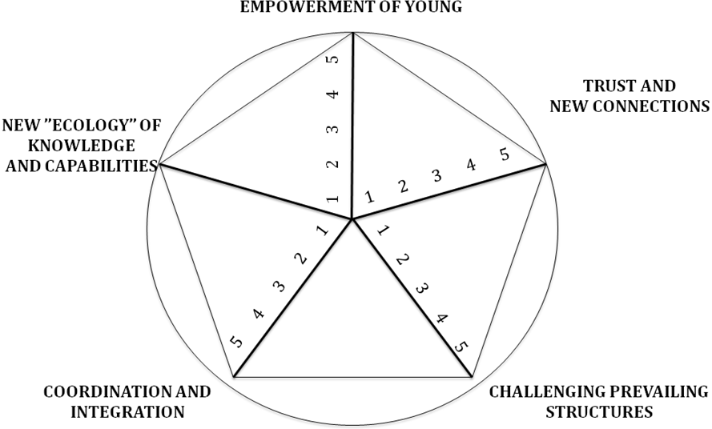
An example:

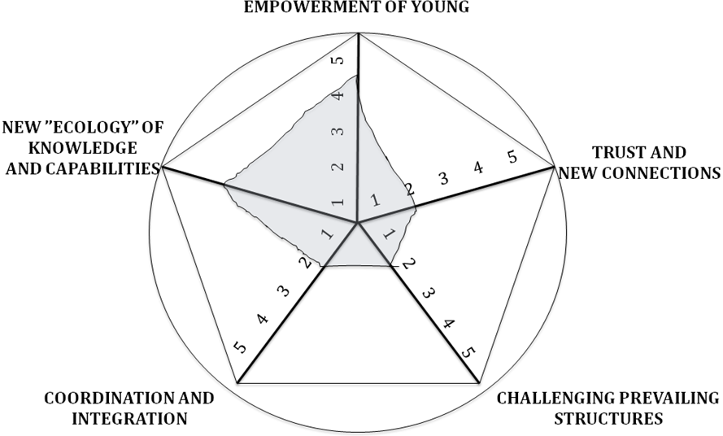

One can see in this example, by a glimpse, that the case/project/example has been strong in empowerment and new ecology, but rather weak on the others, like building trust and new connections, coordination and integration and challenging prevailing structures. This might spell problems for sustainability of the results in the future…
A summary of the feedback will be given in Gdansk and in Gdansk, on every day we would, in a flexible way, pay attention to the dimensions in the discussions, i.e. ask questions and giving examples using the dimensions.

IV Summary of what to do

- Give a brief update of your work in Chapter I
- Get to grips of the self-evaluation dimensions using Chapter II
- Make a self-evaluation (if possible have a small workshop with your project group/ Local Support Group)
- Write down key points of the discussion, complete the Self-Evaluation and draw a SPIDERGRAM (in the powerpoint file!), and send the feedback, together with the update by 7 May to Cleo, Esther, Bob, Ed and Ulf. (c.pouw@obr.rotterdam.nl, e.sprangers@obr.rotterdam.nl, robert.arnkil@armas.fi, eddy@eaconsultants.com, ulf@europeanminds.com )

