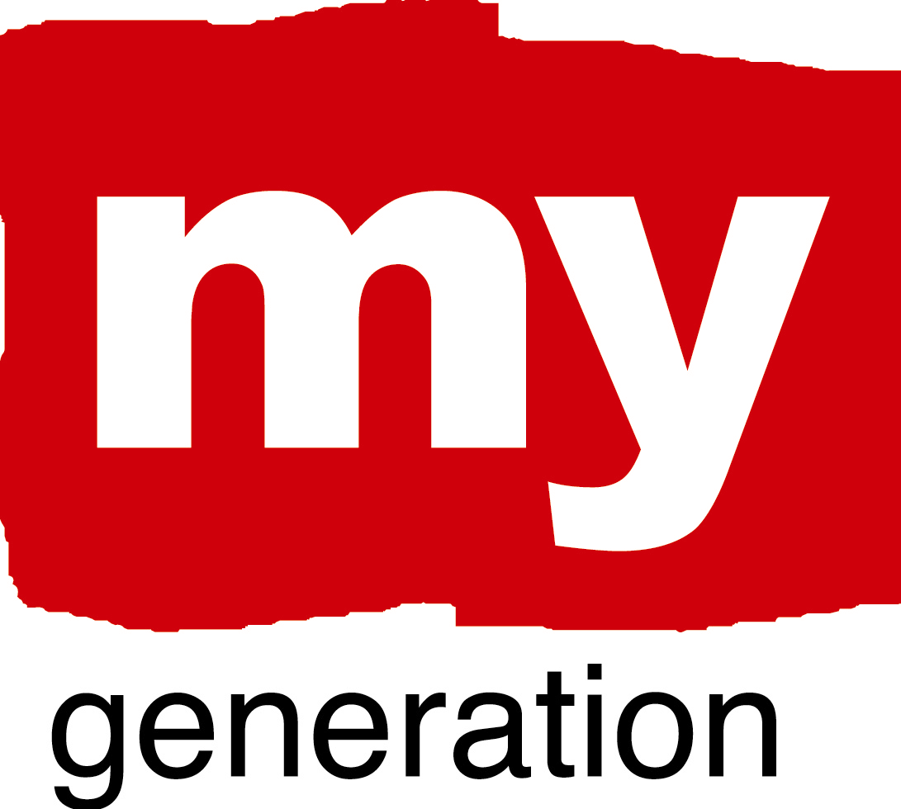
Rotterdam (1)
Youth empowerment in Rotterdam

What is your LAP about?
To ensure the continuation of the positive effects of the 2009 “Rotterdam European Youth Capital” year.
This is done by strengthening the position of young people so that we can jointly (youth and adults) create a city that is attractive to young people in many ways and that provides opportunities for the development of talent.

What are your objectives?
- Development of talent
- Ensure participation
- Connecting young and old
- Upscaling to national level (dissemination of positive effects)
- Making effects visible in the city
- Encouraging youth leadership
- Political commitment

Rotterdam (2)
Where has your work concentrated since Riga-workshop?
- To obtain political approval for a policy plan and budget to structurally continue themost successful initiatives of the Rotterdam European Youth Capital.
- Rotterdam officiall started with tranfering the responsibility of the continuation of the successful initiatives started during the youth capital year 2009 to the Rotterdam Youth Council (and also tranfering capacity and funding to achieve this). Examples of successful projects are:
-Dynamic Duo’s
-Fund for small grants for youth initiatives
-Continuation of the physical meeting space:Your Space, for youth relates events
-Young Mayor and Alderman
And more!
- At this moment, we are brainstorming about how to bring together existing and new initiatives in a MOVEMENT in Rotterdam, which connects and inspires people to keep the European Youth Capital spirit alive.

Rotterdam (3)

Where have you made best and most interesting progress?
- Political commitment to Youth Empowerment policy plan and budget for coming years
- Starting up of thinking process about how to create a (new style) Movement

What (possible) obstacles, problems, questions ?
How to get from a group enthusiastic people to establishing a MOVEMENT to keep the youth capital spirit alive? (do you feel it? what core values, how to organise? When? what is tipping point? whom ?)

How well has your Local Support Group functioned?
Quite well. In Rotterdam, the LSG is an organic, dynamic structure. Many different people and organisations are involved on and off, with a permanent core of people that have been involved from the beginning. More clarity about what we the functioning of the ULSG, and how it can connect to the desired”movement” will be discussed in the next period.

Where is your work with the Local Action Plan at the moment?
The policy plan has been approved. Rotterdam Youth Council is responsible for implementation, with support by Rotterdam Department of Education and Youth.
Concrete plans on the creation of a Movement is still to be developed further.

Rotterdam (4)
Youth empowerment in Rotterdam

Where is your work with the Local Action Plan at the moment?

EMPOWERMENT:

BUILDING TRUST AND NEW CONNECTIONS:

CHALLENGE PREVAILING STRUCTURES AND ACTION:

PROMOTING COORDINATION:

RENEW “PRODUCT ECOLOGY”:

