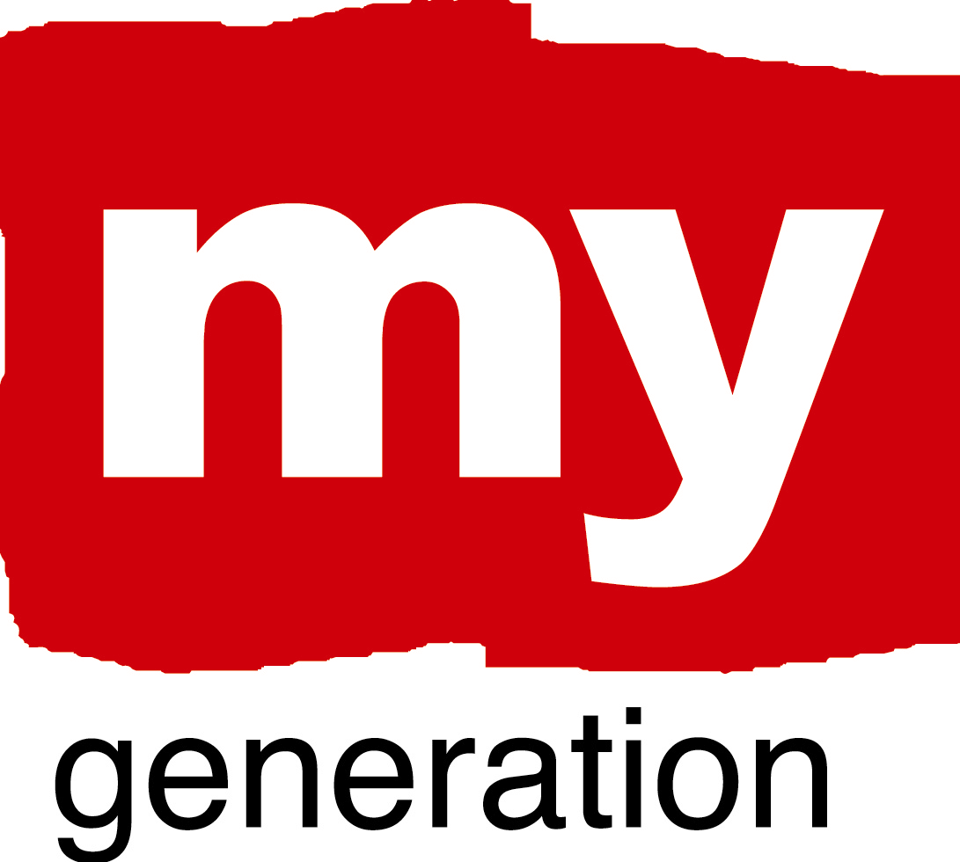
Warsaw (1)
Youth counts in Warsaw

What is your LAP about?
Our LAP is about giving more perspectives for youngsters, especially those from poor districts of city and from families with problems. We will concentrate on showing them positive examples of spending their free time and showing how important is education. We also want to show them through the Youth Council, that they can really decide about thing connected to them – sport, culture, education etc.

What are your objectives?
- Developing tools of getting in better contact with youth.
- Increasing the involvement of politicians and local government representatives in the youth issues.
- The inclusion of employers in the process of educating youth.
- Improving the position of Youth Council as a representatives of young people lived in Warsaw.

Where has your work concentrated since Riga-workshop?
We have concentrated on the involvement of young people in the process. We have also tried to poses new partners.

Warsaw (2)

Youth counts in Warsaw

Where have you made best and most interesting progress?
Our Youth Council started to work fine and we hope that it will still improve. They already have many ideas and they have started talking to Authorities about it –for ex. Snow park as a Youth centre, culture place and meeting point.

What (possible) obstacles, problems, questions ?
We still have problems with improving the engagement of new partners into the MG process.

How well has your Local Support Group functioned?
The engagement of different partners is still too weak.

Where is your work with the Local Action Plan at the moment?
This is actually a beginning of our work with the Local Action Plan. We are collecting different points of view and new ideas. In June we are going to have a few days workshops with our LSG on the Local Action Plan and we hope that it will put us forward.

Warsaw (3)
Youth counts in Warsaw

SELF EVALUATION-SPIDERGRAM

EMPOWERMENT: 4.
This is just a beginning of Youth Council, hopefully with the time some problems will be gone.

BUILDING TRUST AND NEW CONNECTIONS: 3.
Young People are not so “popular” among adults as equal partners.

CHALLENGE PREVAILING STRUCTURES AND ACTION: 4.
In our city there is a possibility to participate in local educational competition for NGO’s related to people from families with difficulties. We also started to employ personal psychological advisors at schools.

PROMOTING COORDINATION: 4.
This is just a beginning of Youth Council, hopefully with the time some problems will be solved.

RENEW “PRODUCT ECOLOGY”: 4
Youth has a free access to the information in the internet at schools, libraries, hot spots in many cultural an social places in Warsaw. There are also some websites for Young People with “who, where and when” information about their City and Youth Council of the City of Warsaw.

