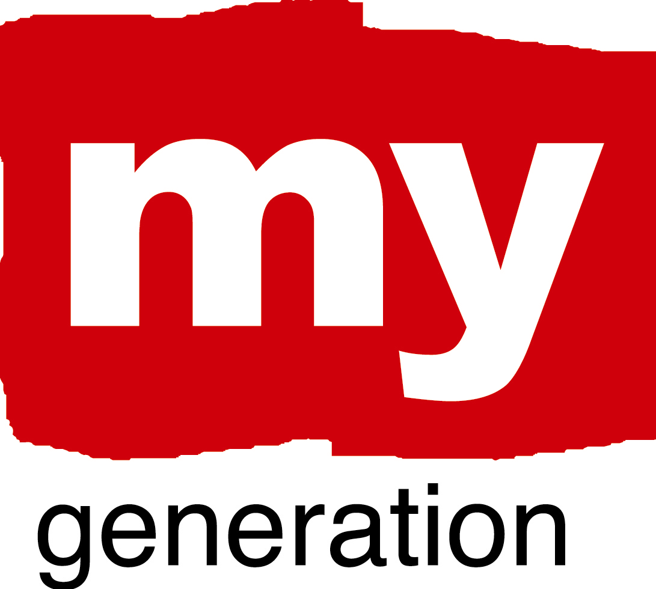
Tirgu-Mures (1)
FUTURE FOR THE YOUTH

What is your LAP about?
It is a strategy/plan identifying the measures/steps to be taken in order to establish the Counselling and Orientation in Career Office. This strategy determines the way this office could function, the resources necessary for the integration of young unemployed and graduate people into society and within their job.

What are your objectives?
1. Objective: Concrete diagnose on the needs/interest of the young people and the tendencies of the local economy, as well as an assessment on the report between request and demand of the workforce for each economic activity in part.
2. Objective: Building up an active, efficient and collaborative partnership between the educational, administrative, economic institutions involved within the young unemployed issue.
3. Objective: Improving the mechanisms within the educational units in order to facilitate the preparation of the young people for the professional qualifications and the specific dynamics of the professional world.
4. Objective: Creating a data base with the relevant information
5. Promoting the informing, counselling services.

Tirgu-Mures (2)
FUTURE FOR THE YOUTH

Where has your work concentrated since Riga-workshop?
Two local workshops have taken place since the Riga workshop, during which an assessment has been made on the current employment, educational situation, underlying the incoherence between the two sectors.
Where have you made best and most interesting progress?
An active involvement has been registered on behalf of the employment and education community, i.e. concrete data (also in figures and percentages) have been received on the unemployment structure according to qualification levels, age categories, on current tendencies in the local economy, on existing school profiles.

What (possible) obstacles, problems, questions?
The problems and obstacles to be mentioned are:
- the inefficient cooperation with the local business community
- challenging the prevailing structures to change the old patterns

How well has your Local Support Group functioned?
These last two local workshops have been very efficient ones since the group members already know each other, they are more open to dialogue and their attitude is more cooperative than before.

Tirgu-Mures (3)
FUTURE FOR THE YOUTH

Where is your work with the Local Action Plan at the moment?
At present the Local Support Group is drawing up the outline/framework of the strategy. It has been concluded that the first part should map the current situation on employment and education in the local context, while the second part should list the objectives and measures set up for the project’s final aim, the establishment of the Office for Counselling and Job Orientation in Career.

SELF EVALUATION-SPIDERGRAM

EMPOWERMENT: 2
The young have no official representation in the local decision taking Council, thus they do not actively participate to the community decision taking processes.
To be improvedt: Young people should be included in the City Council.

BUILDING TRUST AND NEW CONNECTIONS: 3
A good level of connection has been achieved with the employment, education sectors and the local community, while a poor connection is built up with the business community. The public authority bears the though responsibility of building trust in relation with these communities.

Tirgu-Mures (4)
FUTURE FOR THE YOUTH

CHALLENGE PREVAILING STRUCTURES AND ACTION: 2
Messages were sent to some key institutions that need to change their old patterns or methods, eg. The improvement suggested for the School inspectorate was to harmonize the school curricula according to the demands of the local economic needs.

PROMOTING COORDINATION: 2
During the project it has been continuously suggested the idea of partnership, as the only way of progressing in the youth unemployment issue, and even in the first part of the LAP we would like to draw the attention to the fact that this is a complex problem that regards the Education, the Employment, the Business community and the young itself. However, only 2 of these actors seem to have accepted this approach and seem to cooperate well. As an improvement we would see the integration of the business community in this relation while the young people first should have the opportunity to make their voice officially heard.

RENEW “PRODUCT ECOLOGY”: 2
My Generation” offered a platform for the young people involved in this project, to make their voice not only heard but also seriously taken into account in front of important decision-making institution’s representatives, through expressing their perceptions, needs regarding the local context, through elaborating the audio-visual materials and presenting them within the framework of the project, according to their own way of thinking about the respective theme. All these ways of communicating should be encouraged.

