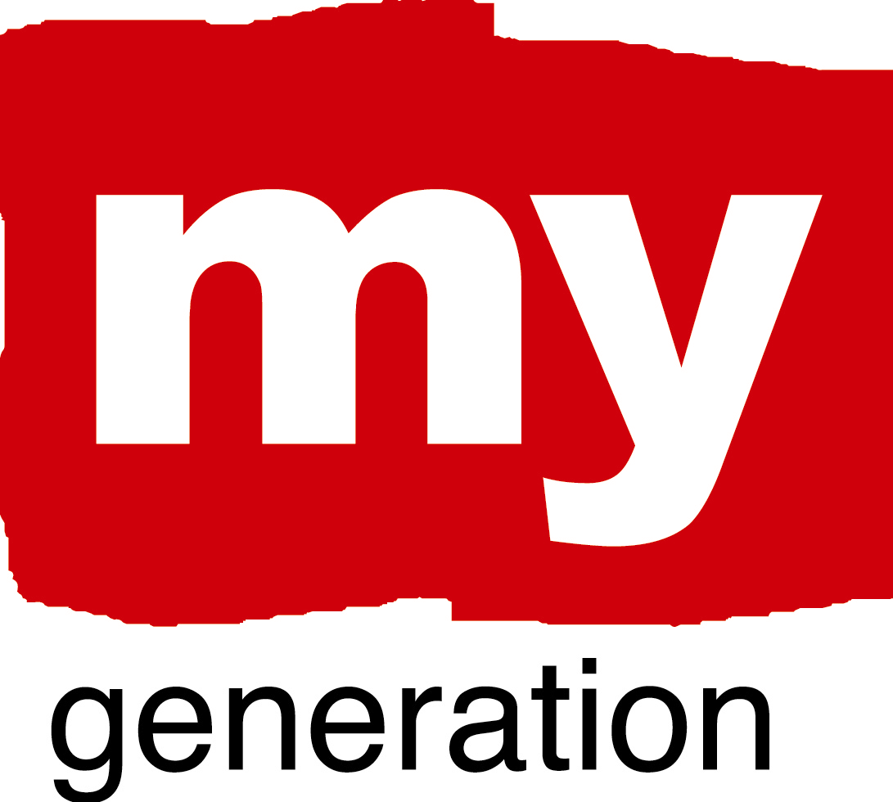
Riga (1)
Riga – youth city, city of opportunities for youth!

What is your LAP about?
The LAP is organised around the “from inactivity and exclusion to active life and self reliance” axe. Therefore it is set on two pillars:
- leisure time and inclusion;
- skills development.
The first one will include leisure time activities for the young (as close to neighbourhoods they live in as possible) and youth information services (to grant excessive information about available opportunities).
The second one will be comprised by the set of non-formal learning opportunities:
- training courses and individual seminars;
- mentoring programmes;
- internship coordination system;
- volunteering coordination system (incl. skills certifying system).
The activities of the LAP will be implemented in partnership between the municipality and NGOs (mostly youth organisations). Additionally, a safety-net is to be created for the young who are not involved into education or employment (or face other challenges) with a set of focused social services and special motivational programmes.

What are your objectives?
The aims and activities predefined for the LAP are to:
- foster participation culture among the young;
- create environment for young people to acquire skills and attitudes required in working life; - provide a joint framework for youth policy interventions from the side of the stakeholders.
Riga (2)
Riga – youth city, city of opportunities for youth!

Where has your work concentrated since Riga-workshop?
The main focus within “My Generation” since January has been on youth participation. A regular dialogue between the youth NGOs and politicians was set (with the help of Youth Organisations’ Consultative Board – institution designed within “My Generation”). The vision of the organisations was presented about how further cooperation in the field of youthwork could be organised. This concept will be used as the basis for the LAP.
Parallelly an effort has been made to ensure networking among the youth organisations themselves. The Board, in this perspective, is becoming a communication platform for youth leaders and a space for developing new initiatives.

Where have you made best and most interesting progress?
The most interesting progress is also in the youth participation field. A consortium of youth NGOs has identified the necessary key actions for strengthening capacity of youth organisations working in Riga. In order to implement them, a democracy project has been developed (under action 1.3. of “Youth in Action”) and will be submitted on 1st June.

What (possible) obstacles, problems, questions ?
Since participation has been the key issue in the last months, other dimensions of the project were put aside in a way. Still, as the LAP will be elaborated further, more attention will be put to the initiative to foster connection between education and business community, as well as to setting the support system for recognition of informal learning via volunteering.

Riga (3)
Riga – youth city, city of opportunities for youth!

How well has your Local Support Group functioned?
As all the organisations represented in the Youth Organisations’ Consultative Board are also involved into the work of LSG, the framework used for cooperation within “My Generation” was the one of the Board. Noteworthy, it has resulted in a higher level of involvement of youth organisations (also those, not “officially” involved into the project).

Where is your work with the Local Action Plan at the moment?
By now the concept of the LAP has been debated with the organisations involved in the LSG and has been informally presented to a wider network of NGOs. The approach chosen for the LAP has gained it approval. Therefore within summer months the first draft will be developed by the drafting team. Wider consultations will follow in early autumn.
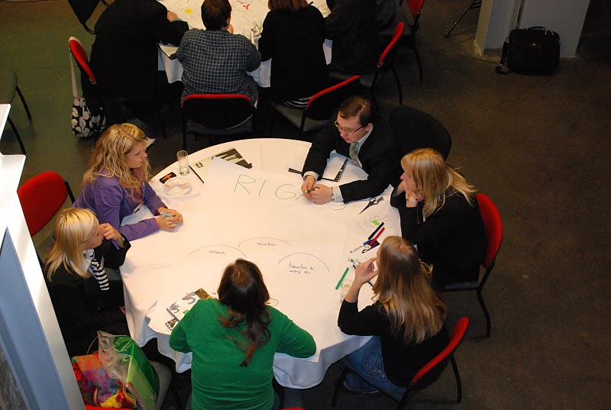

Riga (4)
Riga – youth city, city of opportunities for youth!

SELF EVALUATION-SPIDERGRAM

EMPOWERMENT: 3
Even though the level of involvement of youth organisations in areas tackled by the project has risen, interest of many stakeholders in the project itself has decreased. Therefore a certain effort is necessary to revitalise the network and to include additional players. More attention has to be paid also to the methodology and approach we use on local level, so that “My Generation” is more inclusive and more fun.

BUILDING TRUST AND NEW CONNECTIONS: 2
A set of initiatives was developed within “My Generation”. However, they are not launched yet, which creates the impression of the project slowing down. At the same time there’s not enough of information for the general public about the project. Whereas what regards to the NGOs, most of them already have sufficient networks and are not interested in new long-term networks. In order to improve this dimension of the project, it is necessary to finally launch the preset initiatives and systems. What is more, wider publicity has to be insured (preferably, in cooperation with municipal PR services).

Riga (5)
Riga – youth city, city of opportunities for youth!

CHALLENGE PREVAILING STRUCTURES AND ACTION: 2
There’s a certain progress in developing cooperation among institutions at the lower (officers’ level). However, public opinion and general systems have not been challenged sufficiently yet.
Therefore, to change the paradigms, it is crucial to ensure publicity for the products developed within “My Generation”.

PROMOTING COORDINATION: 1,4
Even though cooperation has been fostered among municipal institutions while working on “My Generation” issues, it is currently mostly in the areas outside of project’s focus (for example, drug prevention).
As further work on the development of the LAP takes place, it is important to involve a wide range of municipal officials.

RENEW “PRODUCT ECOLOGY”: 1
Even though there’s a quite diverse set of creative methods in the youth work field, they are mostly in other areas. Therefore a continuous effort has to be maintained to identify new methods from other cities, so that to adjust them later on to the local perspective.
New methods and approached need to be set not only within the project, but also in the whole youth work system of the city.

