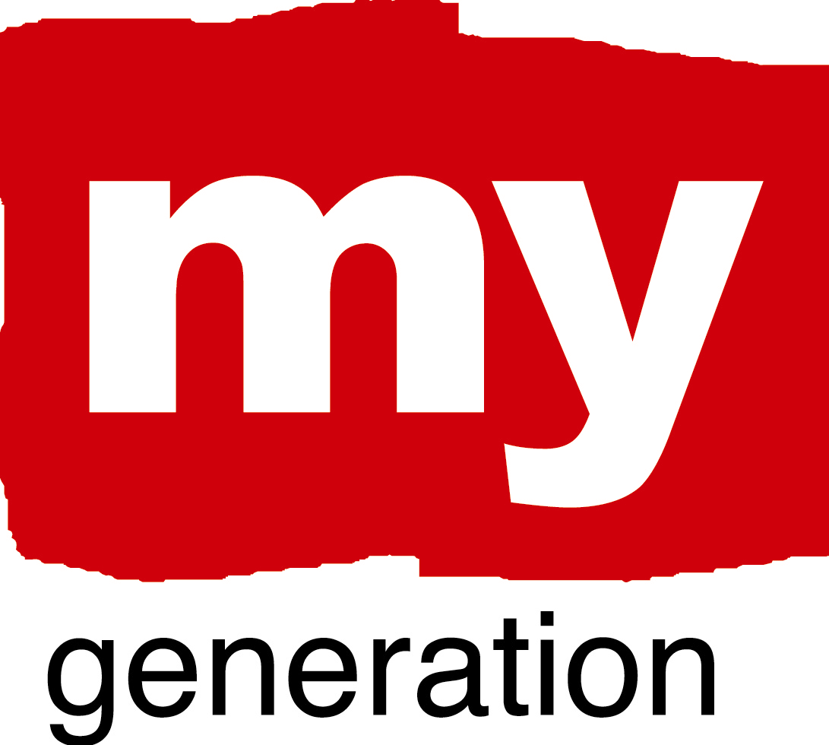
Patras (1)
Patras-YES: Young Energetic Spirit
What is the LAP about?
Patras LAP addresses the following issues:
- Young should be the protagonists in matters for their regard (“for youth with youth”)
- Direct communication and involvement should be enhanced between young people and pupils/students
- Team spirit and team working is of vital importance to every activity
- Businesses need personnel with various skills and not only well educated people- young should invest more in this
- The University (as well as other educational institutions) and the city should be better linked and communicate
- Innovation is a “key” factor when acting “with” youth and “for” youth
- Effectiveness is improved when local authorities are invited by the Managing Authorities to participate in the initial phase of designing the measures that will then be announced for co-financing
- Reveal successful cases organised and implemented by youth, in order to attract other youngsters to be active and also “persuade” those that do not believe much in young people
- Provision of information about youth NGOs of our area

What are your objectives?
- The specific objectives of Patras LAP are:
- To reveal the capabilities of young people
- To familiarise Patras local stakeholders with new types of exchange and cooperation in order to manage diversity and new situation raised at a national and European level
- To explain, to inform and to debate on the richness of youth potential
- To support an equal dialogue between youth NGOs and local authorities
- To engage and/or to improve the engagement of different stakeholders in the construction of common local strategy
- To encourage the exchange of ideas and best practices
- To propose common space of action and shared values
- To give indicative goal setting procedures about youth in municipal level
- To propose procedures of decision making in municipal level by youngsters

Patras (2)
Patras-YES: Young Energetic Spirit

Where has your work concentrated since Riga-workshop?
Effort is being made so that the LAP is the outcome of the exchange and cooperation of the LSG, taking care of exploiting the experience, the knowledge and the suggestions of all partners.
Emphasis is put to enriching the target groups of the LAP, mainly by using the networking of each one of Patras LSG separately, in order to incorporate the various aspects. Therefore, it is envisaged that Patras LAP will target: Patras LSG and their own target groups, youth NGOs, educational institutes, representative associations of SMEs, local authorities and innovation centres.
Another issue that has received further attention is the new “map” of local government organisations (LGO) in Greece which are regarded as part of the “local authorities” target group. This “map” will be changed due to a new respective law known as “KALLEKRATES” scheme. This is a new very significant factor, since it has got a strong impact on new ways of management as well as re-structure of services regarding Greek LGOs. It will be applied to the next Municipal Elections to be taken place in Greece in November 2010, being designed in detail for the moment. When finalised and voted by the current Greek Parliament as a new law, then it should be taken into account for the LAP as well.

Where have you made best and most interesting progress?
Even at the beginning of the exchange with our LSG partners regarding Patras LAP, one of the issues that has been identified as a need, is the lack of an information tool, a type of “guide” of local NGOs. Having such a guide would enhance the provision of information about complementary services and would strengthen networking if exploited fruitfully. ADEP S.A. took the initiative to organise such a guide. As a result, a mechanism was designed and applied in order to identify all such local actors and to record them. The action was agreed as part of Patras LAP and our LSG supported it. This activity is very “mature” nowadays, since a lot of data has been collected. It is expected that the guide will be ready until the end of this year in order to accompany the LAP.

Patras (3)
Patras-YES: Young Energetic Spirit

What obstacles, problems, questions?
The time period after Riga meeting was very crucial for the country of Greece. It is well known that the under-going fight against the “euro” currency and its impact to the “weak” Greek economy lead to new circumstance that the Greek Government and therefore the Greek citizens had to deal with. Special very strong economic measures have been decided and applied already. It is crystal clear that this situation has got a severe impact on people and their behaviour both at a private and professional level. This is the main obstacle to be tackled i.e. being aware of how people feel and manage to maintain targeted to existing programming goals. Based on this, there is a need to incorporate the new conditions through adjustments and changes of ways of managing things.

How well has your Local Support Group functioned?
As already described above, since the Local Support Group involves organisations operated by Greek citizens, they share the same spirit of nowadays in Greece. Most specifically, young people from youth NGOs are extremely frustrated and angry, see no future. However, it is true that the other organisations of our LSG provide the network with a kind of a ”balance”. They are expecting the modified “Operational Plan” of “Western Greece Regional Administration Unit” (Managing Authority) as well as the development measures-laws to be announced by the Government with a more optimistic attitude. This also helps us to cope with the maintenance of the goals set, especially regarding the LAP. It is estimated that the current conditions will mostly affect the ideas of further activities to be presented as part of Patras LAP (please, refer below).
The discussions have prove the need to put emphasis in innovation as a key factor for future actions. As a result, we are thinking of approaching “Patras Science Park” to take part in our LSG – it is regarded as one of the core organisations of our area regarding innovation, start-up and spin-off businesses.

Patras (4)
Patras-YES: Young Energetic Spirit

Where is your work with the Local Action Plan at the moment?
Since, all of us working for the MG project wish to incorporate the moto “for youth with youth” in every action, the LAP is excellent “platform” to achieve it. Our efforts are incorporated under Patras LAP entitled “Patras-YES: Young Energetic Spirit”.
For the time being, the structure of the LAP has been agreed and relative information has been looked for. As it has already been described above, this discussion showed the lack of a guide on local NGOs that should be produced and exploited as a useful information tool. This is an initiative to be funded by ADEP S.A. and not as a product of the MG project. However, it will accompany Patras LAP, as an Appendix. The Business Plan of the Municipality of Patras has been obtained and is being under examination. The objective is to identify those parts of it, that “match” with both the MG project and the content of the LAP. It will accompany Patras LAP, as an Appendix.
A kind of SWOT analysis putting emphasis on the key sectors of development regarding the city of Patras is currently being conducted. There is a difficulty to find statistics since the latest census providing many useful data on the population was completed in 2001.
Emphasis is also put to identifying data related to business activities and the trends of the market – there is a common sense that young people better fit in the attitude of the private sector – even doing business on their own, rather than becoming a civil servant of the public sector. This is regarded of significant importance, especially nowadays, that the operation of the public sector proves to be needing in depth re-structuring.
Furthermore, the modified “Operational Plan-OP” of “Western Greece Regional Administration Unit” (Managing Authority) is expected to be announced soon (it will accompany Patras LAP, as an Appendix). It is obvious, that the OP should be taken into account when linking proposed activities of the LAP benefiting youth, with possible sources of financing.

Patras (5)
Patras-YES: Young Energetic Spirit

SELF EVALUATION-SPIDERGRAM

EMPOWERMENT: 3
The youngsters suggested that more open proposals should be submitted to the politicians and they also stressed the fact that students of Patras University and other youngsters should work together in a more intense way. Moreover, they underlined that the Youth Council should work with more innovative ways and involve more parts of the city.

BUILDING TRUST AND NEW CONNECTIONS: 3
Trust and connections can be reinforces when common ground of actions are undertaken. Most of the stakeholders think and act with prejudices and self fulfilling prophecies that poison relationships and shared values in a way that any new initiative is most of the times doomed to fail.

CHALLENGE PREVAILING STRUCTURES AND ACTION: 2
The message should be sent in a more creative way. Most of the times youngsters can reinforce their power if they find support in other social stakeholders such as NGO’s of different interest, and include their voice in more typical structures such as festivals etc.

Patras (6)
Patras-YES: Young Energetic Spirit

PROMOTING COORDINATION: 2
It is true that there exist many examples of bilateral linking between the actors within the submission of EU projects as well as co-organisation of activities and events. However, there is a need of an “umbrella”. For the moment, ADEP S.A. is playing such a role successfully due to the MG project and the LSG. There is a wish to maintain this coordination after the end of the completion of the MG and perhaps incorporate various other similar local partners. It would be very important if the new Municipality authority to be created after the Municipal Elections in November 2010 had a structure-sector dedicated to youth.

RENEW “PRODUCT ECOLOGY”: 1
No real improvement has been gained within this field. Facebook as well as e-mails and the Web are still the main tools to be used for communicating with youth, which are very common, well known but are not regarded as innovative. On the other hand, they are very effective and user friendly means. It is also noteworthy, that participatory methods incorporating youth, are always applied within the organisation of events for youth. However, it is recognised that the above attitudes and behaviours are not enough regarding innovation and can be further enriched.

