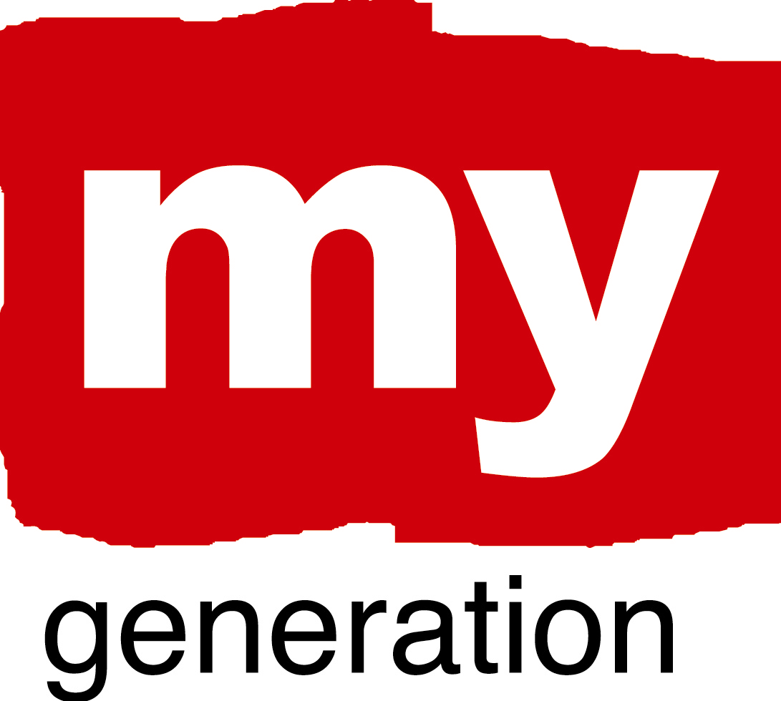
Gothenborg (1)
Gothenborg NeX
What is your LAP about?
Learning for life
Focus on the balance between formal and informal learning
Develop further possibilities for ‘second chances’. Enhance entrepreneurial skills in education. Validate informal competences.
NeXt workforce - Finding employment
Better coordination between different youth labour market initiatives. Increase possibilities for young entrepreneurs. Promote qualitative and innovative work placements for youth. Better understand effects and potential of upcoming generation shift.

NeXt leaders - Forums for dialogue and participation
A need for new forms and forums of youth participation
Develop alternative channels of youth inclusion in decision-making processes. Promote young leaders and informal leadership trainin.

NeXt talents – Creativity, culture and sports
Create alternative and open spaces for creativity, culture and sports. Facilitate the start-up of youth associations and organizations. Evaluate the effects of the ‘Youth Venture’ (Ungdomssatsningen). Develop creative facilities and structures for youth beyond the ‘Youth Venture’ (20+)

Urban planning and development
Highlight the intense use of public transport by youth. Address the problems for young people to find housing
Increasingly include youth in the planning of public spaces and continue the collaborative work on safety and youth crime.

Gothenborg (2)
Gothenborg NeX

What are your objectives?
To develop and improve strategies of coordination. To better include youth in the entire process from planning to decision-makin. To strengthen the connections between education and employment. To apply an integrated, cross-sectional and holistic approach.

Where has your work concentrated since Riga-workshop?
We have had two LSG meetings since January. We formulated an appendix to the politicians concerning youth issues to the city budget of 2011. The LAP working groups have finished and presented their materials. Peer site visits to Rotterdam and Antwerp. Developed our Case study on the Outreach theme. A proposal to apply for the European Youth Capital 2013 has been presented to the political executive board and the Youth Council. Our youth representatives have started a youth association called “My Generation”.

Where have you made best and most interesting progress?
Synergies between different youth initatives within the city (peer sites visits). The appendix about youth issues to the politicians.

What (possible) obstacles, problems, questions?
The progress of the LAP is still not sufficiently grounded at the political level.

Gothenborg (3)
Gothenborg NeX

How well has your Local Support Group functioned?
Most sufficiently! People do attend the meetings and are participating actively. There is still a problem that meetings are held during daytime when the group of youths are still attending school.

Where is your work with the Local Action Plan at the moment?
We have gathered enough materials for the LAP but we still don’t know exactly how to use it or to whom we shall present it. Who is going to use it and in what way, i.e. the politician haven’t really asked for it!

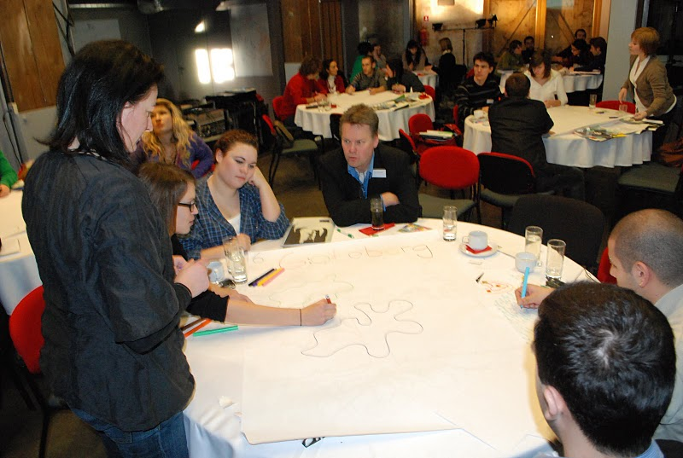
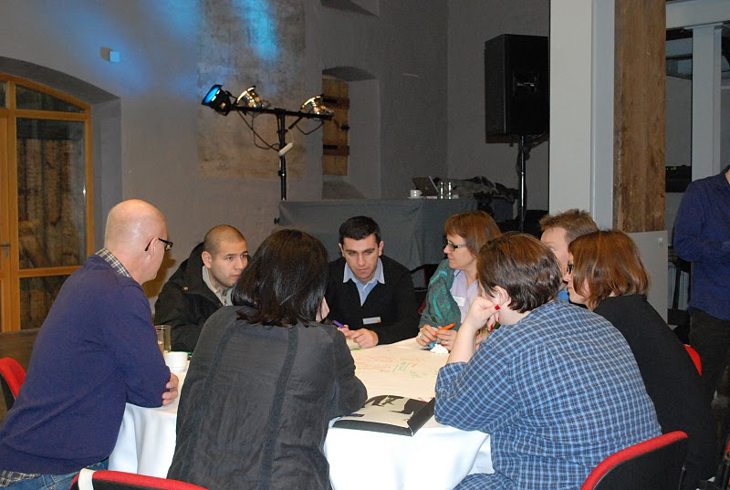

Gothenborg (4)
Gothenborg NeX

SELF EVALUATION-SPIDERGRAM

EMPOWERMENT: 3
Difficult with the traditional meeting forms.

BUILDING TRUST AND NEW CONNECTIONS: 4
Within the LSG-group! There is potential of spreading the experiences in a wider range..

CHALLENGE PREVAILING STRUCTURES AND ACTION: 2
There is more to be done!

PROMOTING COORDINATION: 4
Within the LSG –group! The level of integration has been successful and we hope it can be spread in a wider range

RENEW “PRODUCT ECOLOGY”: 2
There is always a possibility of improvement!

